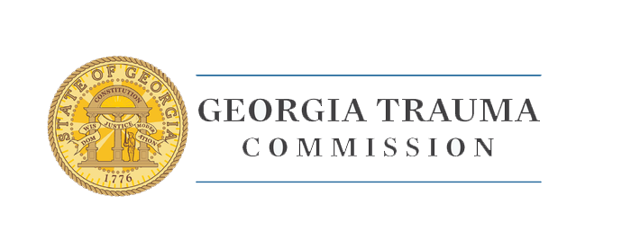

March 22, 2021

Special Request – Equipment not on Approved Equipment List

EMS Trauma Related Equipment for Amended FY 2021 GTCNC Budget

The deadline to submit completed grant packets including your agency application, affidavit and copy of invoice or purchase order for reimbursement is on or before April 30, 2021. If your agency requests equipment not listed on the approved purchase lists provided, please complete the below information and submit no later than April 10th, 2021. Applications received on April 30, 2021 that have not submitted this form but have requested unapproved equipment will be returned to the sender.

AGENCY NAME : _______________

AGENCY CONTACT NUMBER : _______________

Email : _______________

Requested Equipment Detail : _______________________

How will Equipment Improve Care for Trauma Patients :_______
________________________________________________________________________
________________________________________________________________________
________________________________________________________________________

( Please provide cost estimate or any additional detail to be considered for approval)

_________________________________ _______________________
Agency Director Signature Date

If your agency is approved for Equipment purchases we ill notify you by e-mail provided above within 5 days of submission of this request.

