DRAFT FOR APPROVAL

Georgia Trauma Commission EMS Committee
Meeting Minutes
May 7, 2025
Virtual Meeting
Zoom
Recording: https://youtu.be/3MAXuCJ8-pY
Attachments: trauma.ga.gov

COMMITTEE MEMBERS PRESENT | COMMITTEE MEMBERS ABSENT
Courtney Terwilliger, Chair, GTC Member | Pete Quinones, Region Three | GTC Member
Lee Oliver, Vice-Chair, Region Five | Dr. Smith, GTC Member
Scott Stephens, Region One
Jeff Adams, Region Two
Scott Roberts, Region Four
John Smith, Region Six
Duane Montgomery, Region Seven
Allen Owens, Region Eight
Brian Hendrix, Region Nine
Huey Atkins, Region Ten
Terry Cobb, GTC Member

STAFF & OTHER ATTENDEES PRESENT | REPRESENTING
Elizabeth Atkins | Georgia Trauma Commission
Katie Hamilton | Georgia Trauma Commission
Gabriela Saye | Georgia Trauma Commission
Gina Solomon | Georgia Trauma Commission
Crystal Shelnutt | Georgia Trauma Commission
Tim Boone (via Zoom) | AVLS Adminstrator
Kelly Joiner | OEMS/T
Kristal Smith | Region 5 RTAC
Kim Littleton | GEMSA
Cathy White | GEMSA

CALL TO ORDER
Courtney Terwilliger called the meeting to order at 10:00 AM on Thursday, May 7, 2025, with 11 members present.

Approval of FY2025 Final Spend Plan
Presented By Courtney Terwilliger

Courtney clarified that this was a called meeting for the sole purpose of discussing and approving the FY25 Final Spend Allocation Plan. He summarized the reallocation process that Katie, Gabby, and Liz prepared, explaining that funds unspent across programs are pooled and redistributed. Funds will be used to prepay items with existing contracts to ensure expenditures are finalized by June 30.
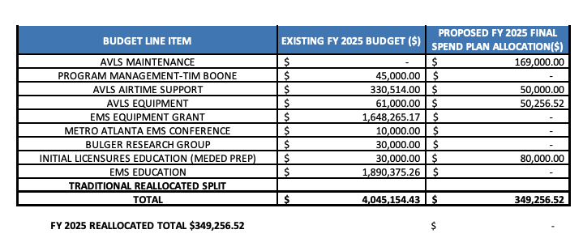

MOTION GTCNC EMS COMMITTEE 2025-5-01:
Motion to approve FY2025 Final Spend Plan as presented.

MOTION BY: John Smith
SECOND BY: Jeff Adams
VOTING: All members are in favor of the motion.
ACTION: The motion PASSED with no objections or abstentions

The meeting adjourned at 10:05 AM following a brief discussion about the next Meeting scheduled for May 22. Due to anticipated budget discussions, it will be a general session, with most standing agenda items likely deferred.

Minutes by C. Shelnutt

