Standards: | 4.31 Trauma Reg Staff (Lev 1-3 & PTC 1-2, p 71)  0.5 FTE reg / 200-300 pt entries (1.0 reg 400-600 pts)  Trauma centers must take into account the additional tasks, beyond the abstraction and entry of patient data assigned to the registrar.  - Processes such as report generation, data analysis, research assistance, and meeting various submission requirements will decrease the amount of time dedicated to the meticulous collection of patient data.  - Electronic downloads into the trauma registry also create additional tasks, as does ongoing data validation before data acceptance. [MAPPING]  - Additional staff will be required to perform these tasks to ensure the integrity and quality of registry data, which are used for prevention, PIPS, and other essential trauma program aspects.  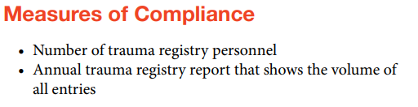
4.32 CAISS
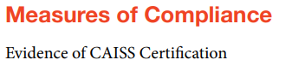
4.33 Trauma Registry Courses - anyone with registry role in data abstraction/entry, injury coding, ISS calculation data reporting, or data validation for the trauma registry must:
- Participate & pass AAAM AIS course; Take trauma registry coarse that includes (abstraction, data management, reports/report analysis, HIPPA; Participate in ICD-10 course every 5yrs
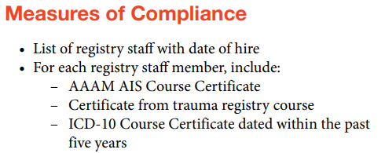
4.34 Trauma Registrar Continuing Education
- 24 hrs trauma-related CE during verification cycle (continuing ED: internal, external, or online); Consultation visit/initial verification review: 8hrs during reporting year
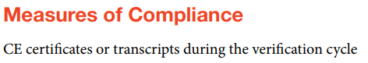
4.35 PI Staffing Requirements
- Pt volume > 1,000 - 1.0 FTE
