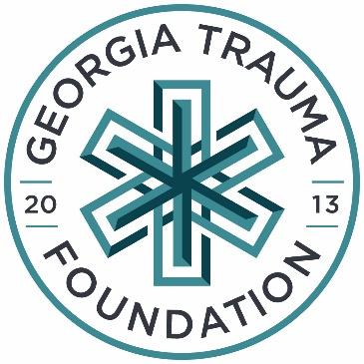

Continuing Education Database Information Sheet

The Georgia Trauma Foundation is building a database that will become an online master list of trauma education providers throughout the state. If you would like to be added to this password protected directory, please complete the information below.

Name: ____________________________________ Email: _________________________________
Cell Phone: ____________________________ Professional Credentials: __________________
Employer: __________________________________________ Employer City: ____________________
County of residence: ___________________________
Which courses are you certified to teach, coordinate or direct?
Course: Role: Expiration:
ATLS ____________________________ __________
RTTDC ____________________________ __________
Hospital Surge Readiness Program ____________________________ __________
ATCN ____________________________ __________
TNCC ____________________________ __________
ENPC ____________________________ __________
PALS ____________________________ __________
PEARS ____________________________ __________
Georgia Trauma Skills Procedure Lab ____________________________ __________
(Cadaver Lab)

Other courses: __________________ ____________________________ __________

If you have any questions or concerns, please feel free to contact Kyndra Holm at kholm@augusta.edu or 410-960-1271. Thank you for supporting excellence in trauma education throughout the state of GA!

Please scan this QR code to complete the survey electronically.
______________________________ __________________ 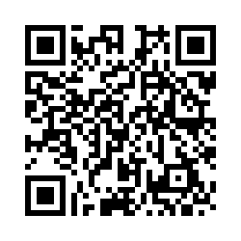
Signature ` Date

