ArborMetrix Log in Tips & Troubleshooting

- New access to the platform can be provided by each facility’s TPM or GQIP Director

- Password resets can be done by facility TPM or GQIP Director

- When logging in, the one-time code requested after username and password has been entered is from the authenticator app user set up by QR code upon activation of account (Authy, Google).
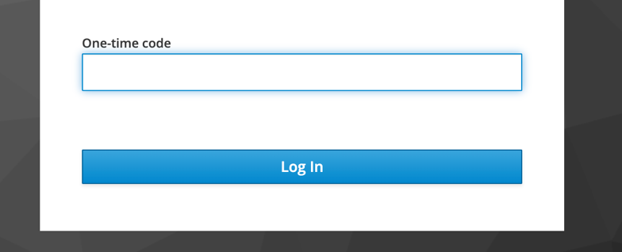

- Issues with authenticator app, (new phone, cannot remember which app, app not sending code) must be resolved by emailing help@arbormetrix.com

