2024 Trauma Data Dictionary

2024 ADMISSION YEAR This dictionary serves as the required data fields and definition requirements referred to as GQIP Trauma Data Standard for use by a Georgia designated trauma center with 2024 admitted trauma patients.

Table of Contents

GENERAL INFORMATION………………………………………………………………………………………………………………………….……….12
ITDX and NTDB FIELDS………………………………………………………………………………………………………………………………………13
2024 Georgia Trauma Registry Inclusion Criteria 19
Demographic: Record Created Date/Time 21
Demographic: Medical Record Number 22
Demographic: Account Number 23
Demographic: LongID (part 1 of 2) 24
Demographic: LongID (part 2 of 2) 25
Demographic: Arrived From 26
Demographic: Armband Number 27
Demographic: Inclusion Information - NTDB 28
Demographic: State Download Inclusion 29
Injury: Chief Complaint 30
Prehospital Provider: POV/Walk in 31
Prehospital: Was Patient Extricated? 32
Prehospital: Time Required/Minutes 33
Prehospital Provider: Agency [state ID & name] 34
Prehospital Provider: Transport Role 35
Prehospital Provider: Scene EMS Report 36
Prehospital Provider: PCR Number (#) 37
PREHOSPITAL PROVIDER: CALL RECEIVED DATE/TIME…………………………………………………………………………………………………..38
Prehospital Provider: Call En Route Date/Time 39
Prehospital Provider: Arrived at Patient Date/Time 40
Prehospital Provider: Scene Time Lapsed 41
Prehospital Provider: Transport Time Lapsed 42
Prehospital Vitals: Paralytic Agents? 43
Prehospital Vitals: Sedated? 44
Prehospital Vitals: Eye Obstruction? 45
Prehospital Vitals: Intubated? 46
Prehospital Vitals: Intubation Method? 47
Prehospital Vitals: Respirations Assisted? 48
Prehospital Vitals: Respirations Assisted - Type? 49
Prehospital Provider: Diastolic Blood Pressure 50
Prehospital Vitals: RTS 51
Prehospital Vitals: Triage RTS 52
Prehospital Procedure: Procedure 53
Prehospital Medication: Medication 54
Prehospital Medication: Medication Date/Time 55
Immediate Referring Facility: Referring Facility 56
Immediate Referring Facility: If Other & Additional Referring Facility 57
Immediate Referring Facility: Admit Date/Time 58
Immediate Referring Facility: Discharge Date/Time & 59
Immediate Referring Facility: Length of Stay 60
Immediate Referring Facility: Transfer Rationale 61
Immediate Referring Facility: Temperature Value 62
Immediate Referring Facility: Temperature Unit 63
Immediate Referring Facility: Temperature Route 64
Immediate Referring Facility: Respirations Assisted? 65
Immediate Referring Facility: Respirations Assisted-Type 66
Immediate Referring Facility: O2 Saturation 67
Immediate Referring Facility: Supplemental O2 68
Immediate Referring Facility: Systolic Blood Pressure 69
Immediate Referring Facility: Diastolic Blood Pressure 70
Immediate Referring Facility: Pulse Rate 71
Immediate Referring Facility: Unassisted Respiratory Rate 72
Immediate Referring Facility: Eye Response on GCS 73
Immediate Referring Facility: Verbal Response on GCS 74
Immediate Referring Facility: Motor Response on GCS 75
Immediate Referring Facility: GCS Total 76
Immediate Referring Facility: GCS 40 Eye 77
Immediate Referring Facility: GCS 40 Verbal 78
Immediate Referring Facility: GCS 40 Motor 79
Immediate Referring Facility: Alcohol Use Indicator 80
Immediate Referring Facility: Drug Screen 82
Additional Vitals: ALL 83
Referring Facility Medications: Medications 84
Referring Facility Procedures: Procedures-ICD10 Code 85
Interfacility Transport: Referring Facility 86
Immediate Referring Facility: Interfacility Transport Mode 87
Inter-Facility Transport: Agency [state ID & name] 88
Inter-Facility Transport: Transport Role 89
Inter-Facility Transport: EMS Report 90
Inter-Facility Transport: PCR Number (#) 91
Inter-Facility Transport: EMS Call Dispatched Date/Time 92
Inter-Facility Transport: EMS Arrived Location Date/Time 93
Inter-Facility Transport: EMS Depart Location Date/Time 94
Inter-Facility Transport: EMS Arrived Destination Date/Time 95
Interfacility Transport: Transport Time Lapsed 96
Interfacility Provider/Vitals: Referring Facility 97
Interfacility Provider/Vitals: Agency 98
Interfacility Provider/Vitals: SBP 99
Interfacility Provider/Vitals: Pulse 100
Interfacility Provider/Vitals: Unassisted Resp Rate 101
Interfacility Provider/Vitals: O2 Saturation 102
Interfacility Provider/Vitals: GCS Total 103
ED/Resus: ED Arrival Date/Time 104
ED/Resus: Direct Admit 105
ED/Resus: Admitting Service 106
ED/RESUS:SIGNS OF LIFE…………………………………………………………………………………………………………………………………………….107
ED/RESUS:MODE OF ARRIVAL………………………………………………………………………………………………………………………………………………………….…….108
ED/Resus: Revised Response Level 109
ED/Resus: Response Activation Date/Time 110
ED/Resus: Revised Response Activation Date & Time 111
ED/Resus: Time in ED 112
ED Arrival/Admission: OR Disposition 113
ED/Resus: Trauma Alert Called in by EMS Date/Time 114
ED/Resus: Response Activation Date/Time 115
ED/Resus: Response Activation Time Lapsed 116
ED/Resus: Revised Response Activation Date/Time 117
ED/Resus: Revised Response Activation Time Lapsed 118
ED/Resus: Temperature Unit (measurement scale) 119
ED/Resus: Temperature Route 120
ED/Resus: Initial Vitals- BMI 121
ED/Resus: Intubation Method 122
ED/Resus: Respiratory Assist Method 123
ED/Resus: Diastolic Blood Pressure (DBP) 124
ED/Resus: Initial Vitals- RTS 125
ED/Resus: Initial Vitals- Triage RTS 126
ED/Resus: Pediatric Trauma Score - Airway 128
ED/Resus: Pediatric Trauma Score – Cutaneous 129
ED/Resus: Pediatric Trauma Score – CNS 130
ED/Resus: Pediatric Trauma Score – Pulse Palp 131
ED/Resus: Pediatric Trauma Score – Total 132
ED/Resus: ABGs Drawn 133
ED/Resus: pH 134
ED/Resus: PaO2 135
ED/Resus: PaCO2 136
ED/Resus: Hematocrit 137
ED/Resus: INR 138
ED/Resus: Base Deficit 139
ED/Resus: Drug Use Indicators 140
ED/Resus: CPR 141
ED/Resus: Mass Blood Protocol 142
ED/Resus: Mass Blood Protocol Date/Time 143
ED/Resus: Mass Blood Protocol Administered 144
Patient Tracking: Stepdown/IMC Days 145
Patient Tracking: Blood Product 146
Patient Tracking: Volume 147
Patient Tracking: Units 148
Patient Tracking: Location 149
Patient Tracking: Time Period 150
Providers/Resus Team: Trauma Provider Specialty 151
Providers/Resus Team: Trauma Called Date/Time 152
Providers/Resus Team: Trauma Arrived Date/Time 153
Providers/Resus Team: Provider Type 154
Providers/Resus Team: Provider Called Date/Time 155
Providers/Resus Team: Provider Responded Date/Time 156
Providers/Resus Team: Provider Arrived Date/Time 157
Providers/Resus Team: Provider Timeliness 158
Providers/Resus Team: Provider Elapsed Time 159
PROVIDERS:IN-HOUSE CONSULTS:TYPE………………………………………………………………………………………………………………………159
Providers/Consults: Called Date 162
Providers/Consults: Arrived Date 163
Providers/Consults: Timeliness 164
Procedures: Location Code & Description 165
Procedures: Operation # 166
Procedures: Stop Date and Time 167
Diagnosis: NISS 168
Diagnosis: TRISS 169
Outcome: Discharge Status 170
Initial Discharge: Patient Directive Applied 171
Initial Discharge: Total Days; Hospital 172
Outcome: Discharged to Alternate Caregiver 173
Outcome: Hospital Disposition 174
Outcome: If Transferred, Facility 175
Outcome: Discharged To- Specify 176
Outcome: Transfer Rationale 177
Initial Discharge: Impediments to Discharge 178
Initial Discharge: Ready to Discharge Date 179
Initial Discharge: Delay Days 180
Outcome: If death: Location (of death) 181
Outcome: Circumstances of Death 182
If Death: Withdrawal of Care 183
Outcome: If death: Was autopsy performed? 184
Outcome: If death: Was Organ Donation Referral Made to LifeLink? 185
OUTCOME: IF DEATH: DID PATIENT QUALIFY AS AN ORGAN DONOR?.......................................................185
Outcome: If death: Organ Donor? 187
Outcome: If death: Was organ donation requested? 188
Outcome: If death: Was request granted? 189
Outcome: If death: Organs Procured 190
If Death:Donor Status 191
If Death: Date and Time Organs Procured 192
QA Items: ACS Questions 193
QA: QA Items 194

General Information

This data dictionary primarily includes data fields outside of the
ITDX + NTDB + TQIP data points. GQIP's data model includes ITDX
+ NTDB + TQIP plus the data fields noted in this dictionary. For the NTDS and TQIP data fields, please refer to the 2024 NTDS Data Dictionary. For ITDX data fields, please refer to the 2024 ESO ITDX Data Dictionary. New fields are highlighted in table of contents & data field pages. Required fields are bold in table of contents.

Below are tables that list the NTDB + TQIP and ITDX Fields
(Courtesy of ESO). The ITDX fields are noted in green. ITDX fields are required except for:
- State Trauma Number
- Regional Trauma Number
- Hospital System Trauma Number
- Transporting EMS Agency NPI Number
- EMS Incident Number
- Lowest ED/Hospital SBP

These fields are currently optional.
Data Sources listed for data points are suggestions on where these might be located except for the EMS data points which should be obtained from the EMS patient care record.

NTDB and ITDX Fields

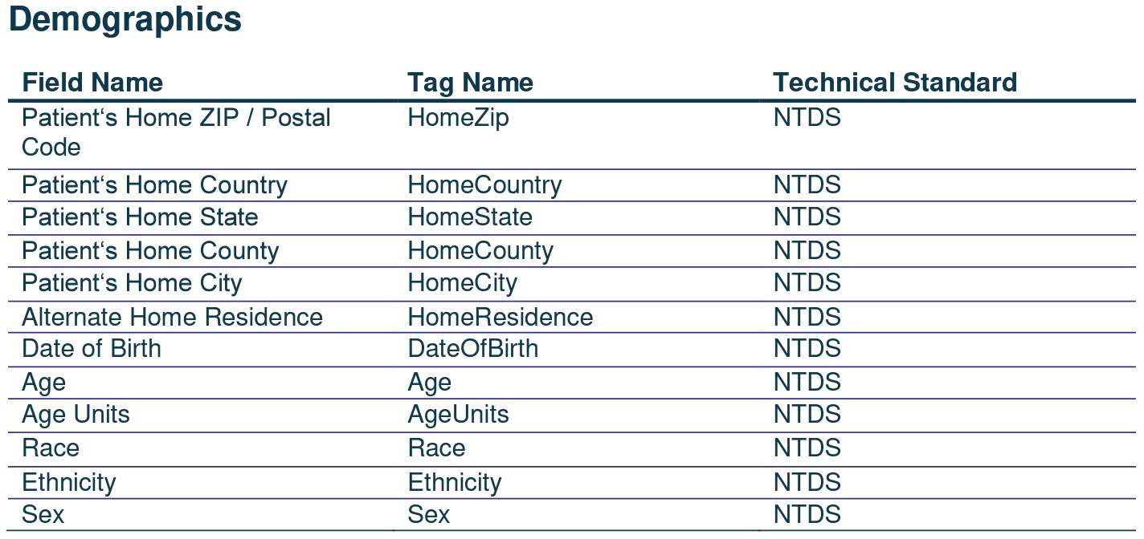

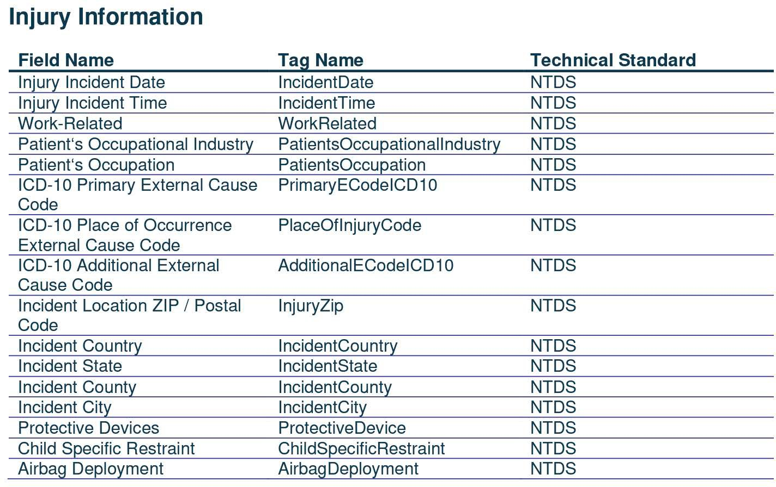

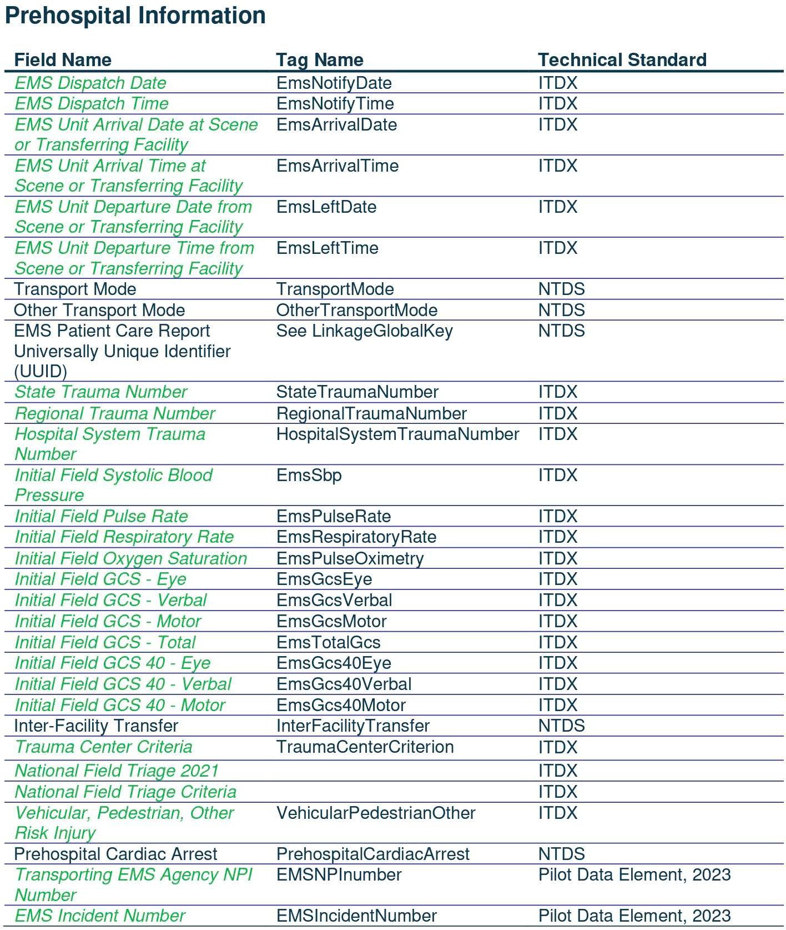

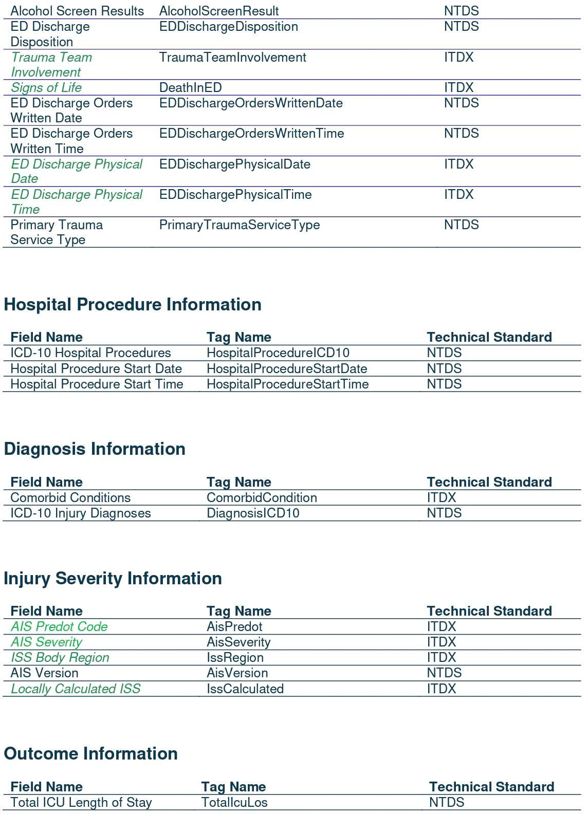

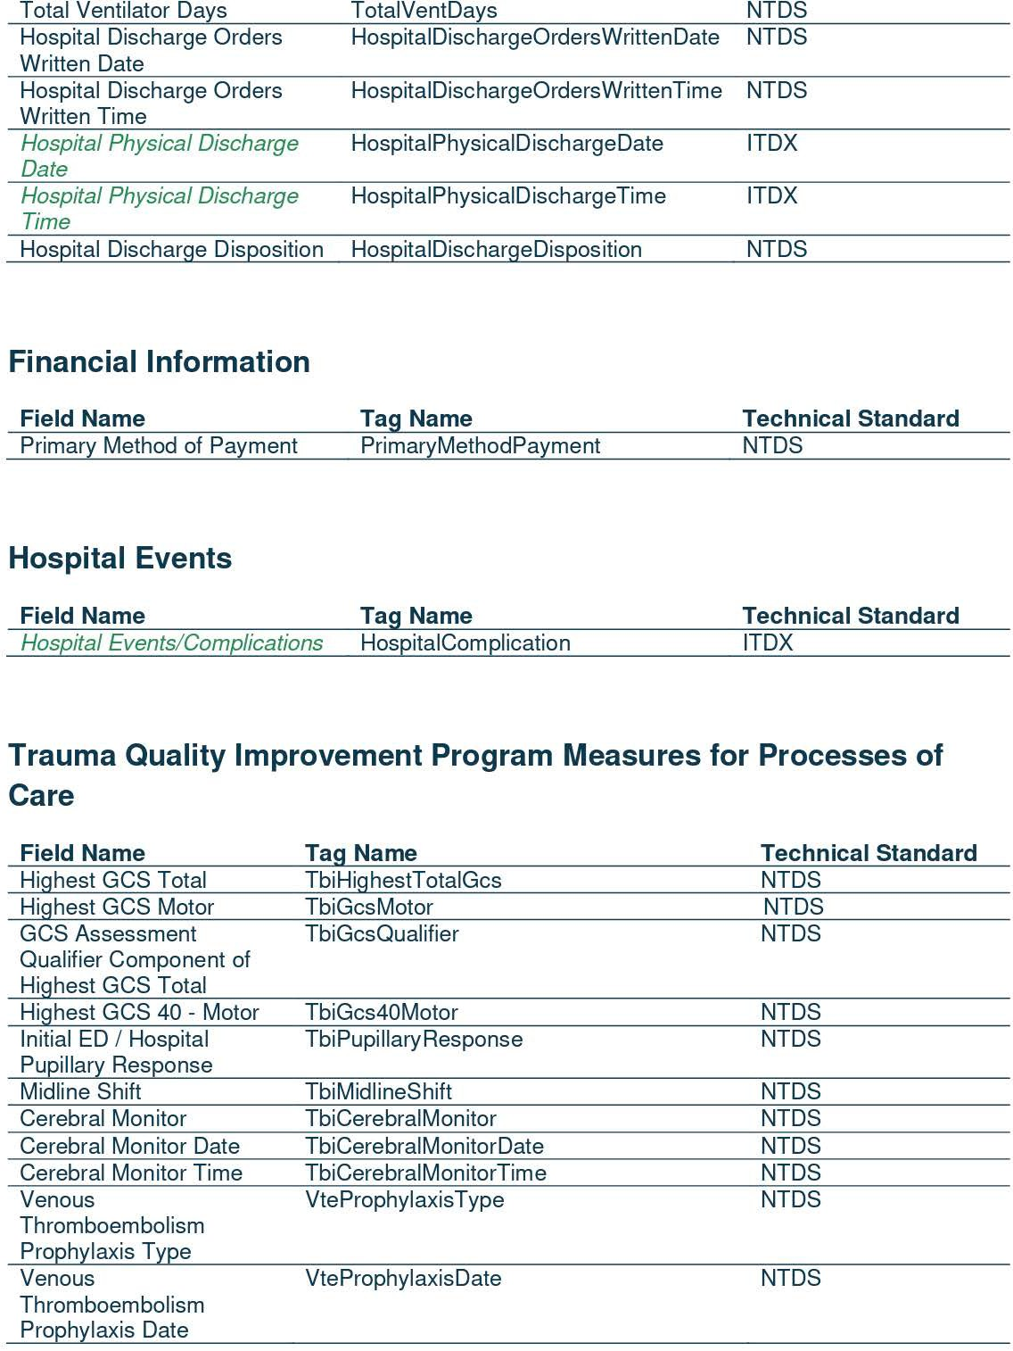

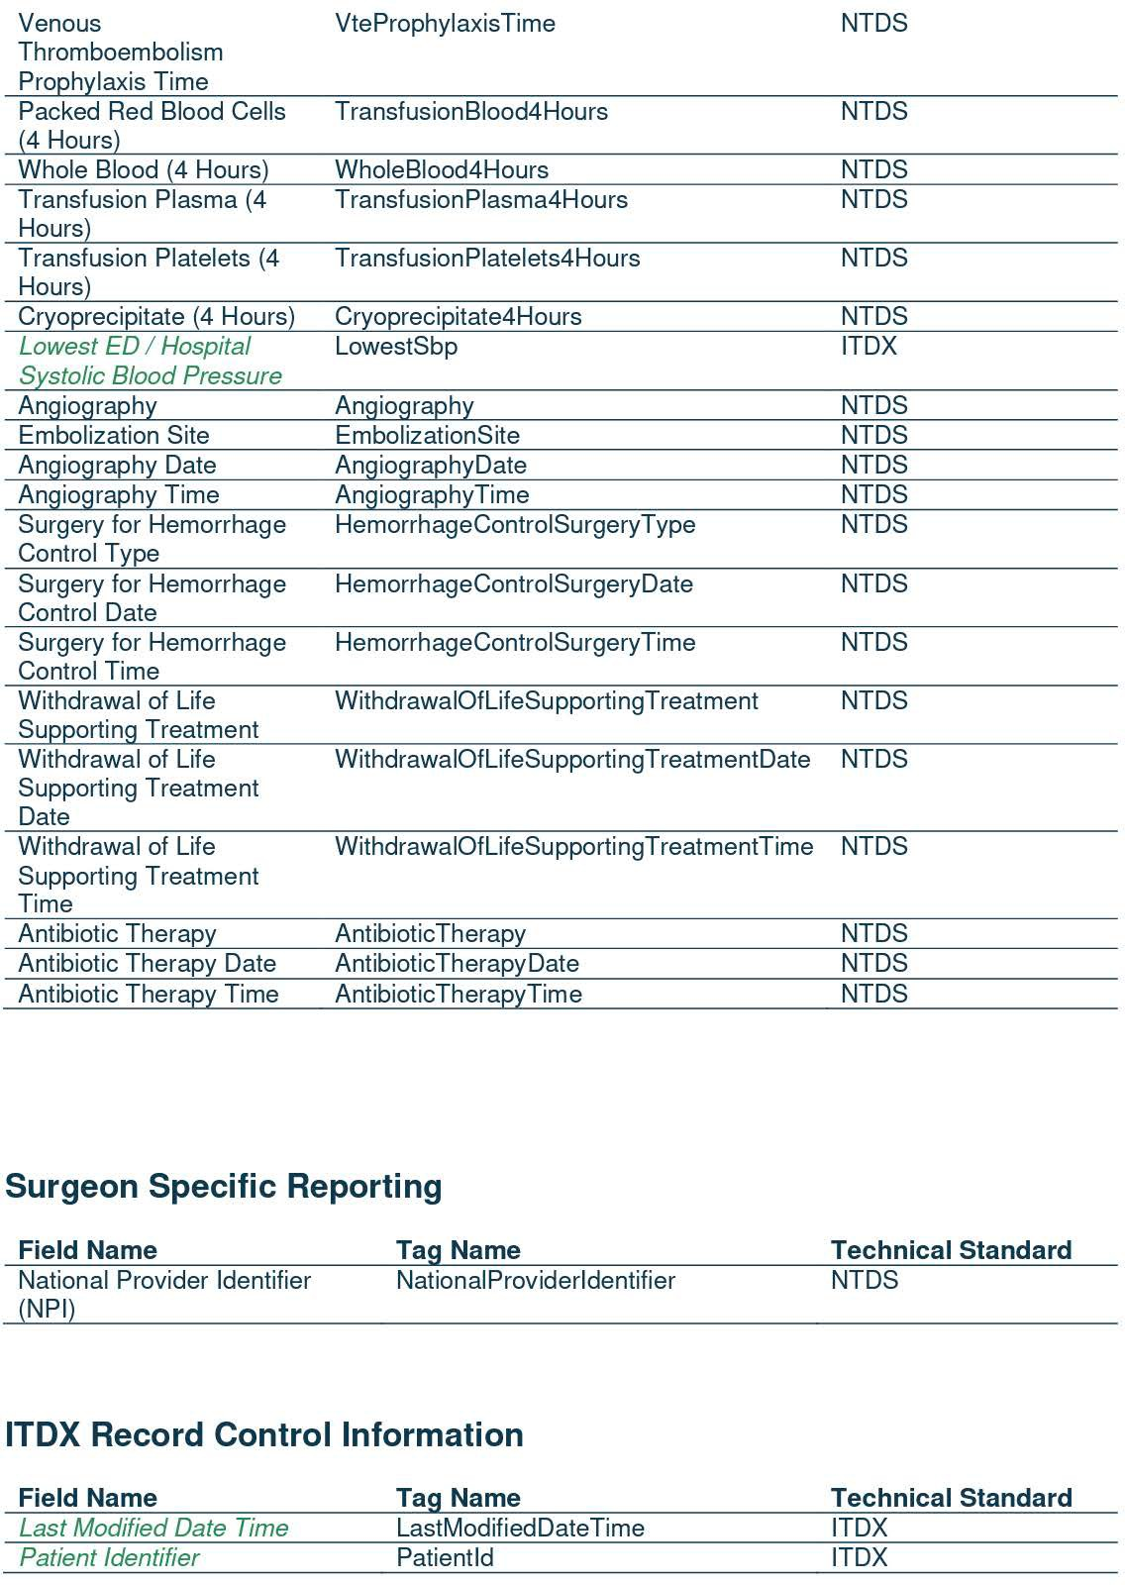

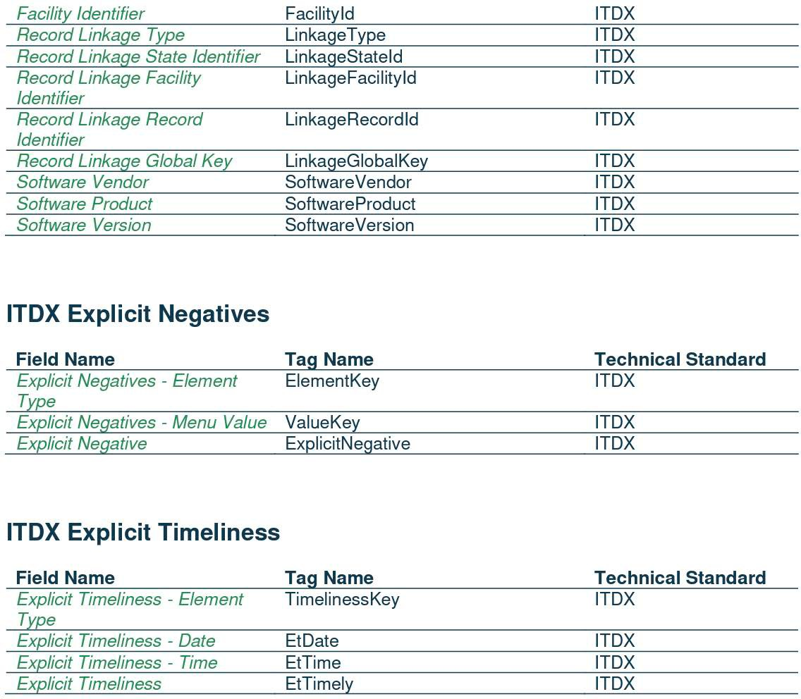

2024 Georgia Trauma Registry Inclusion Criteria
Office of EMS/Trauma
- Include patients presenting with a traumatic injury occurring within 14 days of initial hospital visit and with an ICD-10_CM diagnosis code below:
  - S00-S99 w/ 7th character modifiers of A, B, or C ONLY. Injuries to specific body parts – initial encounter (see exclusions below)
  - T07 (unspecified multiple injuries)
  - T14 (injury of unspecified body region)
  - T20-T28 with 7th character A only or T30-T32 (only with a non-burn trauma dx meeting inclusion criteria)
  - T79.A1 – T79.A9 w/ 7th character modifier A ONLY (Traumatic Compartment Syndrome – initial encounter)
- EXCLUDING:
  - Patients with isolated superficial injuries- Diagnosis codes of ICD-10-CM superficial injuries: S00, S10, S20,
S30, S40, S50, S60, S70, S80, S90
  - Late effect codes w/ the 7th character modifier of D through S
  - Patients w/ isolated burn injuries T20-T28 w/7th modifier A or T30-T32 (NTDS 2021)
  - Patients admitted to a medical or social service w/ a minor trauma injury that would not have been otherwise admitted for their injury. Inclusion decisions are at the discretion of each facility. * (GA 2023)
  - Patients w/ injuries older than 14 days from first ED/hospital arrival date. (NTDS 2021)
  - Patients admitted for elective and/or planned surgical intervention. (NTDS 2022)
  - Patients w/ an In-House trauma injury sustained after the initial ED/Hospital arrival and before ED/Hospital discharge. This exclusion involves all data related to the In-House injury. (NTDS 2022)

- AND must include one of the following in addition to a valid trauma diagnosis code from the listed above
  - Admitted to the hospital after discharge from the ED or directly admitted to the hospital, regardless of length of stay
  - Transferred to or from another acute care facility**
  - Died, regardless of length of stay
  - DOA: defined as a patient that died from a traumatic injury before hospital arrival and was pronounced dead by a physician in the emergency department.

- Additional criteria/notes:
  - The Georgia data collection standard for blood utilization includes data for any blood products administered within the first 4 hours from the patient arrival time.
  - Unplanned readmissions must be associated with the initial trauma injury, have a trauma diagnosis, ISS total, and be readmitted within 72 hours of discharge from the first visit.
  - Dictionary Data Sources are simply a guide; Centers should use the most reliable source at their center.

* Indicates a difference between the Georgia Criteria and the NTDS Criteria
** Per the Centers for Medicare and Medicaid Services, Acute Care Hospital is defined as a hospital capable of providing
inpatient medical care with services for surgery, acute medical conditions, or injuries. “CMS Data Navigator Glossary of

GQIP Data Field Definitions

Demographic: Record Created Date/Time

TAB NAME: Demographic - Record Info ALLOW N/A? NO

V5 REP WRITER NAME:

DEFINITION:

The date and time the record was created.

V5 OPTIONS:

Auto-created
REQUIRED? YES

ALLOW UNK? NO

Demographic: Medical Record Number

TAB NAME:

Demographic, Record Info

REQUIRED? YES

ALLOW N/A? NO

V5 REP WRITER NAME: PAT_REC_NUM
ALLOW UNK? NO

DEFINITION:
The unique identification number assigned as the patient identifier.

ADDITIONAL INFORMATION:
- In some instances, patients are assigned a new medical record number (MRN) when they already have one from a previous encounter. Typically, all the patient’s records will be merged under the latest medical record number. Check with your facility’s Medical Records / Health Information Management Department to determine the standard of practice and use the final MRN assigned to the patient.

DATA SOURCE:
Billing/Registration Form, Admission Form

Demographic: Account Number

TAB NAME: Demographic - Record Info REQUIRED? NO

ALLOW N/A? YES ALLOW UNK? YES

V5 REP WRITER NAME: PAT_ACCOUNT

DEFINITION:

Unique alphanumeric number assigned to the patient's account.

ADDITIONAL INFORMATION:

None

DATA SOURCE:

Billing/registration information, Admission form

Demographic: LongID (part 1 of 2)

TAB NAME: Demographic, Record Info ALLOW N/A? YES
REQUIRED? YES

ALLOW UNK? NO

V5 REP WRITER NAME: LINK_NUM

DEFINITION: The LongID is a variable that will help registry records link with other state data sources. The variable, LONGID, is alphanumeric and has a 15-digit length.
- To create the variable, record the following data in the order listed:
  - the first two letters of the first name,
  - the first and last two letters of the last name,
  - the birth date (date of birth – DOB) in an eight-digit MM/DD/YYYY format and
  - sex as “M” for male, “F” for female, and “U” for unknown or if the patient does not identify as a male or
female,
- No symbols such as apostrophes as in names like O’Connor or slashes (“/”) like those in birth dates separating
the month, day and year should be included in the values of LONGID.
- Suffixes such as “Jr.”, “Sr.”, “II” or “III” shall not be considered when creating the values for LONGID.
- Some names have few letters, e.g., Ray, Coe or Li. In such circumstances, letters will be used repeatedly but in the same order as described above.
- Some names have two parts separated by space or a hyphen, e.g., Di Napoli, Ramirez-Martinez, Jones Smith. Regardless of the separator between the two parts, always use the first two letters of the first part and the last two letters of the last part of the compound names.
- If the name and date of birth are unknown, use the names Jane Doe for a female or John Doe for a male and the date of birth January 1, 1900.
- If the sex is unknown or the patient does not identify as a male or female, use “U” for unknown as the sex.

ADDITIONAL INFORMATION:
  - Applies to all patients.
  - Not applicable should not be used.

DATA SOURCE:
Hospital Patient Registration, Billing information, ED MD care note, History & Physical (H&P), ED Nursing Assessment, ED Nursing Notes, EMS PCR

Demographic: LongID (part 2 of 2)
Examples:
  - Subject’s first name is Michael, last name is Thompson, DOB: May 9, 1924 the LONGID will be:
o MI + TH + ON + 05091924 + M = “MITHON05091924M”
  - Subject’s first name is D'Arcy and last name is O'Brien, DOB: 04/15/1932 then the LONGID will be
o DA + OB + EN + 04151932 + F = “DAOBEN04151932F”
  - Subject’s first name is William, the last name is Ray, DOB: February 23, 1940 then the LONGID will be
o WI + RA + AY + 02231940 + M = “WIRAAY02231940M”
  - Subject’s first name is Edward, last name is Li, born on December 6, 1946 then the LONGID will be
o ED + LI + LI + 12061946 + M = “EDLILI12061946M”
  - Subject’s first name is Anthony, last name is De Virgilio, born on September 15, 1956 then the LONGID will be
o AN + DE + IO + 09151956 + M = “ANDEIO09151956M”
  - If the first name is Paula, the last name is Ramirez-Martinez, DOB: January 9, 1960 then the LONGID will be
o PA + RA + EZ + 01091960 + F = “PARAEZ01091960F”
  - Subject’s first name is John, the last name is Jones-Smith, DOB: May 29, 1955 then the LONGID will be JO + JO + TH + 0529195 + M = “JOJOTH05291955M”
  - Subject’s first name is Jane, the last name is Doe, DOB: January 1, 1900 then the LONGID will be
JA + DO + OE + 01011900 + F = “JADOOE01011900F”
  - Subject’s first name is John, the last name is Doe, DOB: January 1, 1900 then the LONGID will be JO + DO + OE + 01011900 + M = “JODOOE01011900M”
  - Subject’s sex is unknown, first name is Michael, last name is Thompson, DOB: May 9, 1924 the LONGID will be:
o MI + TH + ON + 05091924 + U = “MITHON05091924U”
  - Subject’s sex is unknown, first name is Michelle, last name is Thompson, DOB: May 9, 1924 the LONGID will be:
o MI + TH + ON + 05091924 + U = “MITHON05091924U”
  - Subject’s first name is Jane, the last name is Doe, DOB: January 1, 1900 then the LONGID will be JA + DO + OE + 01011900 + U = “JADOOE01011900U”
  - Subject’s first name is John, the last name is Doe, DOB: January 1, 1900 then the LONGID will be
JO + DO + OE + 01011900 + U = “JODOOE01011900U”

Demographic: Arrived From

TAB NAME:

Demographic - Record Info

REQUIRED? YES

ALLOW N/A? NO ALLOW UNK? YES

REP WRITER NAME: PAT_ORIGIN

DEFINITION:
Patient’s immediate location before arriving at your facility. Answer choices include:

Scene
Referring Hospital Home
Other
? Unknown

ADDITIONAL INFORMATION:

  - Applies to all patients.
  - Not applicable should not be used.

DATA SOURCE:
ED MD care note, History & Physical (H&P), ED Nursing Assessment, ED Nursing Notes, EMS PCR, Referring Hospital records

Demographic: Armband Number

TAB NAME: ALLOW N/A?

Demographic - Patient

YES (until implemented statewide)
REQUIRED? YES

ALLOW UNK? NO

REP WRITER NAME: TRAUMA_BAND

DEFINITION: The armband identification number is printed on a colored armband provided by the state to providers.

ADDITIONAL INFORMATION:
  - Enter value - N/A until armband is IN USE.
  - The purpose of the armband number is to represent a Key Patient Identification Number that can be used to link multiple local, state, and national databases.
  - The DPH Office of EMS Trauma plans to distribute armbands to providers and provide education in the near future on the purpose and use statewide.
  - The armband will be placed on the patient by the first care provider. The first provider may be a public health agency, EMS, police, or hospital ED.
  - The armband should remain on the patient from initial contact by the first provider through rehabilitation
or the patient’s final destination of care.
  - The armband number will be useful in local, state, and national emergencies.

DATA SOURCES:
EMS PCR, ED/Trauma EMR or flowsheet

Demographic: Inclusion Information - NTDB

TAB NAME: Demographic - Record Info ALLOW N/A? NO

V5 REP WRITER NAME: REGINC_YN01_AS_TEXT
To read answer as text, add “_AS_TEXT”
otherwise, field info returns as a number

DEFINITION:
Indication if the record meets NTDB inclusion criteria.

V5 Options:

Yes No

ADDITIONAL INFORMATION:
    - Choosing No blocks record from being sent to NTDB/TQIP

DATA SOURCE:
N/A
REQUIRED? YES

ALLOW UNK? NO

Demographic: State Download Inclusion

TAB NAME: ALLOW N/A?

Demographic - Patient

NO
REQUIRED? YES

ALLOW UNK? N O

REP WRITER NAME: REGINC_YN02_AS_TEXT
To read answer as text, add “_AS_TEXT”
otherwise, field info returns as a number

DEFINITION: Does the registry record meet the Georgia Trauma Registry Criteria? Answer choices include: Yes No

ADDITIONAL INFORMATION:
- Selecting Yes causes the registry software to include the record in the download file sent to the Georgia Trauma Registry central site.
- All records marked Yes must meet the Georgia Trauma Registry Criteria, be “Validated” and “CLOSED”
to be included in the download file.
- Selecting No, blocks the record from being downloaded to the Georgia Trauma Registry central site, regardless of the Closed record status.
- Selecting No does not block the record from being downloaded to the GQIP central site.

Injury: Chief Complaint

TAB NAME: Injury, Mechanism of Injury, ICD10 ALLOW N/A? NO
REQUIRED? YES

ALLOW UNK? YES

REP WRITER NAME: INJ_MECH01_AS_TEXT
To read answer as text,
add “_AS_TEXT”, otherwise field info returns as a number

DEFINITION:
A general, simplified description of the ICD 10 cause of injury code. Answer choices include:

MVC
Fall Under 1m Fall 1m - 6 m Fall over 6m Fall - NFS Assault Motorcycle Pedestrian Bicycle
Other Blunt Mechanism Knife
Handgun Shotgun

ADDITIONAL INFORMATION:
Other Gun Glass Biting
Other Penetrating Chemical Burn Inhalation Burn Thermal Burn Electrical Burn
Other Burn Mechanism Other Motorized Vehicle

? Unknown

- The first chief complaint value captured should reflect the primary reason the patient is admitted to the hospital and should directly reflect the ICD-10 Primary External Cause Code (the mechanism causing the injury—e.g., gun, knife, MVC, fall, etc.).
- In cases of assault or abuse, “Assault” should be captured as the SECOND complaint. Assault should only be captured as the first chief complaint if no other mechanism applies (e.g., bodily force, fist fight without weapon).
- Other chief complaints:
Golf cart/ATV/Go Kart/Segway = 23. Other Motorized Vehicle Dirt bike/Motor Scooter/Moped = Motorcycle
Unknown type gun/BB gun/Pellet Gun = Other Gun

DATA SOURCE:
EMS Patient Care Report (PCR), Triage/Trauma Flowsheet, History & Physical/Progress/Nurse Notes

Prehospital Provider: POV/Walk in

TAB NAME: ALLOW N/A?

Prehospital, Scene/Transport

NO
REQUIRED? YES

ALLOW UNK? NO

REP WRITER NAME: PH_POV_YN _AS_TEXT
To read answer as text,
add “_AS_TEXT”, otherwise field info returns as a number

DEFINITION:
Identification if patient arrived by private means, privately owned vehicle (POV) or walked in to first hospital.

Answer choices include:
Yes No

ADDITIONAL INFORMATION
- If the patient arrives to the ED via any type of Emergency Medical Services transport, answer NO.
- If the patient arrives to the ED via law enforcement/police, answer NO.
- If the patient arrives to the ED via any OTHER type of transport answer YES.

DATA SOURCE:
Triage/Trauma Flowsheet, History & Physical/Progress/Nurse Notes, Registration notes, EMS Patient Care Record (PCR)

Prehospital: Was Patient Extricated?

TAB NAME: Prehospital: Scene/Transport REQUIRED? NO

ALLOW N/A? YES ALLOW UNK? YES

V5 REP WRITER NAME: PH_EXT_YN

DEFINITION:
Was the patient removed/released from the vehicle by emergency response team?

V5 OPTIONS:

Yes No
/ Not Applicable
? Unknown

ADDITIONAL INFORMATION:
  - May be in narrative of PCR or extrication section

DATA SOURCE:
EMS Patient Care Record

Prehospital: Time Required/Minutes

TAB NAME: Prehospital: Scene/Transport REQUIRED? NO

ALLOW N/A? YES ALLOW UNK? YES

V5 REP WRITER NAME: PH_EXT_MINS

DEFINITION:
If the patient was extricated, the time in minutes to complete the extrication.

V5 OPTIONS: N/A

ADDITIONAL INFORMATION:
  - May be in narrative of PCR or extrication section

DATA SOURCE:
EMS Patient Care Record

Prehospital Provider: Agency [state ID & name]

YES YES
TAB NAME: | Prehospital, Scene/Transport | REQUIRED?
ALLOW N/A? | YES | ALLOW UNK?

REP WRITER NAME: PHP_AGNCLNKS_L_AS_TEXT
To read answer as text,
add “_AS_TEXT”, otherwise field info returns as a number

DEFINITION:
Identification of the emergency medical services (EMS) agency providing prehospital care and transport from the scene to a facility. Answer choices are contained in a drop-down menu but are not displayed due to space constraints.

ADDITIONAL INFORMATION:
- All EMS Agencies are listed in a pick list in the registry program. Start typing the name to find the correct agency. The state ID number will auto populate when an agency name is chosen.
- The null value “Not Applicable” is used only for patients who were not transported by EMS.
- The value “Unknown” is used if the EMS Agency number is not available in the medical record.
- If you are unable to locate a Georgia EMS agency in the pick list, use the generic code listed below and notify the State Trauma Registrar or Office of EMS Trauma at trauma@dph.ga.gov .
- EMS Agencies outside of Georgia are not listed in the registry software. If an out of state EMS Agency brings a patient to a Georgia trauma center, use the applicable generic state EMS Agency number listed in the pick list. The surrounding Georgia generic state EMS Agency codes in the pick list are as follows:
If EMS agency name not available | Agency # | Agency Name
Georgia | 2020999 | Georgia EMS generic
Out of state EMS agency? Alabama | 50100 | Alabama EMS generic
Florida | 51200 | Florida EMS generic
Louisiana | 54900 | Louisiana EMS generic
Mississippi | 54800 | Mississippi EMS generic
North Carolina | 53700 | North Carolina EMS generic
South Carolina | 54500 | South Carolina EMS generic
Tennessee | 54700 | Tennessee generic

DATA SOURCE: EMS PCR, Trauma Flowsheet,

Prehospital Provider: Transport Role

TAB NAME: Prehospital, Scene/Transport ALLOW N/A? YES
REQUIRED? YES
ALLOW UNK? YES

REP WRITER NAME: PHP_ROLES_AS_TEXT
To read answer as text,
add “_AS_TEXT”, otherwise field info returns as a number

DEFINITION:
Identification of the emergency medical services (EMS) agency role to provide transport to first facility. Answers choices include:
Non-Transport
Transport from Scene to Facility Transport from Scene to Rendezvous Transport from Rendezvous to Facility Transport to Other
Transport from Non-Scene Location
/ Not Applicable
? Unknown

ADDITIONAL INFORMATION:
- This field applies to all patients who arrive by EMS and should not be left blank.
- The null value “not applicable” is reported for patients who were not transported by EMS.

DATA SOURCE:
Triage/Trauma Flowsheet, ED EMR, Nursing notes, hospital registration information, EMS Patient Care Record (PCR)

Prehospital Provider: Scene EMS Report

TAB NAME: Prehospital, Scene/Transport ALLOW N/A? YES
REQUIRED? YES

ALLOW UNK? YES

REP WRITER NAME: PHP_RP_DETAILS _AS_TEXT
To read answer as text,
add “_AS_TEXT”, otherwise field info returns as a number

DEFINITION:
Availability of the EMS patient care report (PCR) access through the Georgia EMS Information System (GEMSIS) Hospital Hub or provided by the EMS service. Answers may include:

Complete Incomplete Missing Unreadable
? Unknown
/ Not Applicable

ADDITIONAL INFORMATION:
- Applies to all patients transported by EMS.
- N/A only used if patient was not transported by EMS

DATA SOURCE:
EMS Patient Care Record (PCR)

Prehospital Provider: PCR Number (#)

TAB NAME: ALLOW N/A?
YES

Prehospital, Scene/Transport
REQUIRED? YES

ALLOW UNK? YES

REP WRITER NAME: PHP_PCR_NUMS

DEFINITION:
EMS Patient Care Report (PCR) Number Response number. The number can be a numerical or alpha-numeric digit number depending on the EMS provider and EMS software used. The number is a unique number assigned to each patient care report per medical encounter. The number will not be duplicated by another EMS provider.

ADDITIONAL INFORMATION:
- Applies to all patients transported by EMS.
- The null value "Not Applicable" should be reported to indicate that the patient did not arrive by EMS.
- The null value "Not Known/Not Recorded" should be reported if PCR is missing.
- The null value "Not Known/Not Recorded" should be reported if PCR is incomplete and/or the number cannot be located.

DATA SOURCE:
EMS Patient Care Record (PCR)

NEW FIELD

Prehospital Provider: Call Received Date/Time

TAB NAME:

ALLOW N/A?
Prehospital, Scene/Transport

YES
REQUIRED? NO

ALLOW UNK? YES

Report Writer Name:
TBD

Definition: The date/time the 911 or PSAP call was received.

Additional Information:
- Applies to all patients transported by EMS.
- Reported as MM-DD-YYYY and HH:MM (military) for time.
- The null value “Not Applicable” is reported for patients who were NOT transported by EMS to the first facility.

Data source:
EMS Patient Care Record (PCR)

Prehospital Provider: Call En Route Date/Time

TAB NAME: Prehospital: Scene/Transport REQUIRED? NO

ALLOW N/A? YES ALLOW UNK? YES

V5 REP WRITER NAME: TBD

DEFINITION:
The date the unit is en route to the reported scene of injury.

V5 OPTIONS:
N/A

ADDITIONAL INFORMATION:
  - Reported as MM-DD-YYYY and HH:MM (military) for time
  - The null value Not Applicable is reported for patients who were NOT transported by EMS to the first facility.

DATA SOURCE:
EMS Patient Care Record

Prehospital Provider: Arrived at Patient Date/Time

TAB NAME: Prehospital: Scene/Transport REQUIRED? NO

ALLOW N/A? YES ALLOW UNK? YES

V5 REP WRITER NAME: TBD

DEFINITION:

The date the unit arrived to the patient.

V5 OPTIONS:

N/A

ADDITIONAL INFORMATION:
- Reported as MM-DD-YYYY and HH:MM (military) for time
- The null value “Not Applicable” is reported for patients who were NOT transported by EMS to the first facility.

DATA SOURCE:
EMS Patient Care Record

Prehospital Provider: Scene Time Lapsed

TAB NAME: Prehospital: Scene/Transport REQUIRED? YES

ALLOW N/A? YES ALLOW UNK? YES

V5 REP WRITER NAME: PHP_ELAPSEDSC

DEFINITION:
The elapsed amount of time from when the unit arrived at the location to when they departed the scene.

V5 OPTIONS:

N/A

ADDITIONAL INFORMATION:
- Auto calculated from scene arrival and scene depart fields

DATA SOURCE:
EMS Patient Care Record

Prehospital Provider: Transport Time Lapsed

TAB NAME: Prehospital: Scene/Transport REQUIRED? YES

ALLOW N/A? YES ALLOW UNK? YES

V5 REP WRITER NAME: PHP_ELAPSED2SC

DEFINITION:
The elapsed amount of time from when the unit arrived at the location to when they departed the scene.

V5 OPTIONS:

N/A

ADDITIONAL INFORMATION:
- Auto calculated from scene depart and arrived at destination fields

DATA SOURCE:
EMS Patient Care Record

Prehospital Vitals: Paralytic Agents?

TAB NAME: Prehospital: Treatment REQUIRED? NO

ALLOW N/A? YES ALLOW UNK? YES

V5 REP WRITER NAME: PHAS_PAR_YNS

DEFINITION:
Were paralytic agents in place for the patient when vitals were taken?

V5 OPTIONS:

Yes No
/ Not Applicable
? Unknown

ADDITIONAL INFORMATION:
- The null value Not Applicable is reported for patients who were NOT transported by EMS.

DATA SOURCE:
EMS Patient Care Record

Prehospital Vitals: Sedated?

TAB NAME: Prehospital: Treatment REQUIRED? NO

ALLOW N/A? YES ALLOW UNK? YES

V5 REP WRITER NAME: PHAS_SED_YNS

DEFINITION:
Was patient sedated when vitals were taken?

V5 OPTIONS:

Yes No
/ Not Applicable
? Unknown

ADDITIONAL INFORMATION:
- The null value Not Applicable is reported for patients who were NOT transported by EMS.

DATA SOURCE:
EMS Patient Care Record

Prehospital Vitals: Eye Obstruction?

TAB NAME: Prehospital: Treatment REQUIRED? NO

ALLOW N/A? YES ALLOW UNK? YES

V5 REP WRITER NAME: PHAS_E_OB_YNS

DEFINITION:
Were the patient's eyes obstructed when vitals were taken?

V5 OPTIONS:

Yes No
/ Not Applicable
? Unknown

ADDITIONAL INFORMATION:
- The null value Not Applicable is reported for patients who were NOT transported by EMS.

DATA SOURCE:
EMS Patient Care Record

Prehospital Vitals: Intubated?

TAB NAME: Prehospital: Treatment ALLOW N/A? YES

V5 REP WRITER NAME: PHAS_INTUB_YNS

DEFINITION:
Was the patient intubated when vitals were taken?

V5 OPTIONS:

Yes No
/ Not Applicable
? Unknown

REQUIRED? NO ALLOW UNK? YES

ADDITIONAL INFORMATION:
- The null value Not Applicable is reported for patients who were NOT transported by EMS.

DATA SOURCE:
EMS Patient Care Record

Prehospital Vitals: Intubation Method?

TAB NAME: Prehospital: Treatment ALLOW N/A? YES

V5 REP WRITER NAME: PHAS_INTUB_M01S

DEFINITION:
If the patient was intubated, what method was used?

V5 OPTIONS:
Combitube Cricothyrotomy Cricothyrotomy-Needle Endotracheal Tube
Nasal Endotracheal Tube Oral Endotracheal Tube Route NFS
Esophageal Obturator Airway
Laryngeal Mask Airway
LT Blind Insertion Airway Device Tracheostomy
? Unknown

ADDITIONAL INFORMATION:
- Opens only if Intubated Y

DATA SOURCE:
EMS Patient Care Record
REQUIRED? NO

ALLOW UNK? YES

Prehospital Vitals: Respirations Assisted?

TAB NAME: Prehospital: Treatment REQUIRED? NO

ALLOW N/A? YES ALLOW UNK? YES

V5 REP WRITER NAME: PHAS_ARR_YNS

DEFINITION:
Was the patient's respiration assisted when vitals were taken?

V5 OPTIONS:

Yes No
/ Not Applicable
? Unknown

ADDITIONAL INFORMATION:
- Use N/A for those not transported by EMS

DATA SOURCE:
EMS Patient Care Record

Prehospital Vitals: Respirations Assisted - Type?

TAB NAME: Prehospital: Treatment REQUIRED? NO

ALLOW N/A? NO ALLOW UNK? YES

V5 REP WRITER NAME: PHAS_ARR_TYPES

DEFINITION:
If patient's respiration was assisted, what type was used?

V5 OPTIONS:

Bag Valve Mask Nasal Airway Oral Airway Ventilator
? Unknown

ADDITIONAL INFORMATION:
- Opens only if resp assisted Y

DATA SOURCE:
EMS Patient Care Record

Prehospital Provider: Diastolic Blood Pressure

TAB NAME:
NTDB FIELD?

Prehospital, Scene/Transport
Accepted

REQUIRED?
ALLOW UNK? YES
YES

ALLOW N/A? YES
REP WRITER NAME: PHAS_DBPS

DEFINITION:
Diastolic Blood Pressure recorded by prehospital providers.

ADDITIONAL INFORMATION:
- Direct entry. First recorded DBP by the Prehospital Provider.
- :-4 = Not Recorded (V5)
- :-5 = Not Available (V5)
DRAF
- The null value “Not Applicable” is reported for patients who were NOT transported by EMS.
- Even if Prehospital Provider: Transport Role is 8 (Transport from Non-Scene Location), enter ALL pre- hospital vitals.

DATA SOURCE:
EMS Provider Patient Care Report

Prehospital Vitals: RTS

TAB NAME: Prehospital: Treatment REQUIRED? NO

ALLOW N/A? NO ALLOW UNK? YES

V5 REP WRITER NAME: PHAS_RTS_WSC

DEFINITION:
The Revised Trauma Score based on vitals measured at the scene of injury. Consists of Glasgow Coma Scale, Systolic Blood Pressure and Respiratory Rate.

V5 OPTIONS:
N/A

ADDITIONAL INFORMATION:

  - Auto-calculated field

DATA SOURCE:
EMS Patient Care Record

Prehospital Vitals: Triage RTS

TAB NAME: Prehospital: Treatment REQUIRED? NO

ALLOW N/A? NO ALLOW UNK? YES

V5 REP WRITER NAME: PHAS_RTS_USC

DEFINITION:
The Revised Trauma Score based on vitals measured at the scene of injury. Consists of Glasgow Coma Scale, Systolic Blood Pressure and Respiratory Rate.

V5 OPTIONS:

N/A

ADDITIONAL INFORMATION:
  - Auto-calculated field

DATA SOURCE:
EMS Patient Care Record

Prehospital Procedure: Procedure

TAB NAME: Prehospital: Treatment ALLOW N/A? YES

V5 REP WRITER NAME: PH_INTS_L_AS_TEXT

DEFINITION:
The procedures performed on the patient at the scene of injury.

V5 OPTIONS:

N/A

ADDITIONAL INFORMATION:
- None

DATA SOURCE:
EMS Patient Care Record
REQUIRED? NO

ALLOW UNK? YES

Prehospital Medication: Medication

TAB NAME: Prehospital: Treatment ALLOW N/A? YES

V5 REP WRITER NAME: PH_MEDS_L_AS_TEXT

DEFINITION:
The medications administered to the patient at the scene of injury.

V5 OPTIONS:

N/A

ADDITIONAL INFORMATION:
- None

DATA SOURCE:
EMS Patient Care Record
REQUIRED? NO

ALLOW UNK? YES

Prehospital Medication: Medication Date/Time

TAB NAME: | Prehospital: Treatment | REQUIRED? NO
ALLOW N/A? | YES | ALLOW UNK? YES

V5 REP WRITER NAME:

DEFINITION:
The date and time the medications were administered to the patient at the scene of injury.

V5 OPTIONS:

N/A

ADDITIONAL INFORMATION:
- None

DATA SOURCE:
EMS Patient Care Record

Immediate Referring Facility: Referring Facility & Additional Referring Facility: Referring Facility

TAB NAME: ALLOW N/A?

Referring Facility, Referral History
YES
REQUIRED? YES

ALLOW UNK?
REP WRITER NAME: RFS_FACLNK_AS_TEXT
To read answer as text,
add “_AS_TEXT”, otherwise field info returns as a number

DEFINITION:
Acute care facility where patient received care immediately before transfer.

ADDITIONAL INFORMATION:
- Hospital providers are listed in the registry program. Start typing the name to find the correct hospital. The state ID number will auto populate when a hospital name is chosen.
- The null value “Not Applicable” is used only for patients who were not received from another facility.
- If you are unable to locate a Georgia hospital in the pick list, please contact the State Trauma Registrar or Office of EMS Trauma at trauma@dph.ga.gov. Facilities change names periodically for various reasons and the name may have changed in the registry program. New facilities must be added to the registry program. If a facility is not available as a choice, use one of the following (as applies):

If facility name not available | Facility # | Facility Name
Georgia (not designated) | 10000 | Acute Care Hospital, Non-Desgd, Unsp (GA)
Georgia (designated trauma center) | 20000 | Acute Care Hospital, trauma hospital, Unsp (GA)
Georgia | 99999 | Georgia Hospital (unspecified)
Out of state? Alabama | 16000 | Alabama Hospital
Florida | 15000 | Florida Hospital
North Carolina | 13000 | North Carolina Hospital
South Carolina | 19010 | South Carolina Hospital
Tennessee | 19020 | Tennessee Hospital
Texas | 91900 | Texas Hospital
Other States | 17000 | Other state specified
Unspecified state | 40000 | Unspecified state
Air Force Hospital | 14010 | Moody
 | 14015 | Warner Robins
U.S. Naval Services | 14030 | U.S.N.S. Comfort
U.S. Penitentiary | 15090 | Penitentiary Hospital
U.S. Virgin Islands | 14040 | Virgin Islands Hospital

DATA SOURCE:
Referring Hospital Medical Record, EMS Patient Care Report (PCR), ER nursing notes, ER MD documentation, History & Physical (H&P), Consult note, Outside facility documentation

Immediate Referring Facility: If Other & Additional Referring Facility

TAB NAME: Referring Facility: Referral History REQUIRED? NO

ALLOW N/A? YES ALLOW UNK? YES

V5 REP WRITER NAME: RFS_FAC_S

DEFINITION:
Free text to specify name of referring hospital that is not listed in referring facility menu.

V5 OPTIONS:

N/A

ADDITIONAL INFORMATION:
  - If specific name of hospital is not available pick appropriate option per referring facility data dictionary page (i.e Alabama Hospital) then type facility name in If Other.

DATA SOURCE:
Referring Hospital Medical Record, EMS Patient Care Report (PCR), ER nursing notes, ER MD documentation, History & Physical (H&P), Consult note, Outside facility documentation

Immediate Referring Facility: Admit Date/Time & Additional Referring Facility: Admit Date/Time

TAB NAME: ALLOW N/A?

Referring Facility, Referral History
YES
REQUIRED? YES

ALLOW UNK? NO

REP WRITER NAME: RFS_A_DATE
RFS_A_TIME
RFS_A_EVENT (list date/time together)

DEFINITION:
The date and time the patient arrived at the Acute care facility where the patient received care immediately before transfer.

ADDITIONAL INFORMATION:
- Report as MM-DD-YYYY and HH:MM (military) for time.
- This is the date/time on which the patient arrived at the referring facility prior to being transferred to your facility.
- The null value “Not Applicable” is used only for patients who were not received from another facility.

DATA SOURCE:
Referring Hospital Medical Record, EMS Patient Care Report (PCR), ER nursing notes, ER MD documentation, History & Physical (H&P)

Immediate Referring Facility: Discharge Date/Time &
Additional Referring Facility: Discharge Date/Time

TAB NAME: ALLOW N/A?

Referring Facility, Referral History
YES

REQUIRED? YES

ALLOW UNK? NO

REP WRITER NAME: RFS_DIS_DATE
RFS_DIS_TIME
RFS_DIS_EVENT (list date/time together)

DEFINITION:
The date and time the patient departed from the Acute care facility where the patient received care immediately before transfer.

ADDITIONAL INFORMATION:
- Report as MM-DD-YYYY and HH:MM (military) for time.
- This is the date/time on which the patient departed from the referring facility prior to being transferred to your facility.
- The null value “Not Applicable” is used only for patients who were not received from another facility.

DATA SOURCE:
Referring Hospital Medical Record, EMS Patient Care Report (PCR), ER nursing notes, ER MD documentation, History & Physical (H&P)

Immediate Referring Facility: Length of Stay & Additional Referring Facility: Length of Stay

TAB NAME: Referring Facility: Referral History REQUIRED? YES

ALLOW N/A? NO ALLOW UNK? YES

V5 REP WRITER NAME: RFS_LOS

DEFINITION:
The length of time the patient was hospitalized at the immediate referring facility.

V5 OPTIONS:

N/A

ADDITIONAL INFORMATION:
  - Auto populates from referring facility arrival and discharge time.

DATA SOURCE:
Referring Hospital Medical Record, EMS Patient Care Report (PCR), EMTALA Form, Outside facility documentation

Immediate Referring Facility: Transfer Rationale

TAB NAME:

Referring Facility, Referral History
REQUIRED? YES

ALLOW N/A? YES ALLOW UNK? NO

REP WRITER NAME: RFS_XFR_RATS

DEFINITION:
The transfer rationale is the trauma system related reason the trauma patient was transferred to the receiving facility. For example, if the trauma patient required a Hand specialty service and one was not available at the referring hospital, the transfer rationale recorded by the receiving facility is Specialty – Hand.

Specialty Resource Center Hospital of Choice Insurance/Health Plan Repatriation
Specialty Care/Higher Level of Care
Resources Unavailable (Beds, Equipment, Staff, MD) Patient Request
Lower Level of Care Economic
Managed Care Patient System Protocol Physician/Services Available Other
Specialty-Pediatrics Specialty-Hand Specialty-Spine
Specialty-Pelvic Ring/Acetabular Fxs
Specialty-Orthopedics-Soft Tissue Coverage
Specialty-Other Orthopedics Specialty-Neurosurgery Specialty-Replantation
Specialty-Vascular/Aortic Injuries Specialty-Cardiac Bypass
Specialty-Facial Trauma
Specialty-Burns
Ear, Nose and Throat Ophthalmology
Plastic Surgery Orthopedic-Spine
/ Not Applicable
? Unknown

ADDITIONAL INFORMATION:
- For inter-facility transfer patients, this is the trauma system related reason for the transfer to your facility.
- If the reason for the transfer is unknown by the receiving facility, choose 4. Specialty Care/ Higher Level of Care
- The null value “Not Applicable” is used only for patients who were not received from another facility.

DATA SOURCE:
Referring Hospital Medical Record, EMS Patient Care Report (PCR), ER nursing notes, ER MD documentation, History & Physical (H&P), Consult note

Immediate Referring Facility: Temperature Value

TAB NAME: Referring Facility: Assessments ALLOW N/A? NO

V5 REP WRITER NAME: RFAS_TEMP

DEFINITION:
Recorded temperature by referring facility.

V5 OPTIONS:

N/A

ADDITIONAL INFORMATION:
  - None

DATA SOURCE:
Referring Hospital Medical Record, Outside facility documentation
REQUIRED? NO

ALLOW UNK? YES

Immediate Referring Facility: Temperature Unit

TAB NAME: Referring Facility: Assessments ALLOW N/A? NO

V5 REP WRITER NAME: RFAS_TEMP_UT

DEFINITION:
The unit used to record temperature, Fahrenheit or Celsius.

V5 OPTIONS:

F. or C.

ADDITIONAL INFORMATION:
- None

DATA SOURCE:
Referring Hospital Medical Record, Outside facility documentation
REQUIRED? NO

ALLOW UNK? YES

Immediate Referring Facility: Temperature Route

TAB NAME: Referring Facility: Assessments REQUIRED? NO

ALLOW N/A? NO ALLOW UNK? YES

V5 REP WRITER NAME: RFAS_TEMP_R

DEFINITION:
The method used to measure the patient's temperature.

V5 OPTIONS:

Oral Tympanic Rectal Axillary Core Other Temporal
? Unknown

ADDITIONAL INFORMATION:
    - None

DATA SOURCE:
Referring Hospital Medical Record, Outside facility documentation

Immediate Referring Facility: Respirations Assisted?

TAB NAME: Referring Facility: Assessments ALLOW N/A? NO

V5 REP WRITER NAME: RFAS_ARR_YN

DEFINITION:
Was the patient's respiration assisted when vitals were taken?

V5 OPTIONS:

Yes No
? Unknown

ADDITIONAL INFORMATION:
  - None

DATA SOURCE:
Referring Hospital Medical Record, Outside facility documentation
REQUIRED? NO

ALLOW UNK? YES

Immediate Referring Facility: Respirations Assisted-Type

TAB NAME: Referring Facility: Assessments REQUIRED? NO
ALLOW N/A? NO ALLOW UNK? YES

V5 REP WRITER NAME: RFAS_ARR_TYPE

DEFINITION:
If patient's respiration was assisted, what type was used?

V5 OPTIONS:

Bag Valve Mask Nasal Airway Oral Airway Ventilator
? Unknown

ADDITIONAL INFORMATION:
- None

DATA SOURCE:
Referring Hospital Medical Record, Outside facility documentation

Immediate Referring Facility: O2 Saturation

TAB NAME: Referring Facility: Assessments REQUIRED? NO

ALLOW N/A? NO ALLOW UNK? YES

V5 REP WRITER NAME: RFAS_SAO2

DEFINITION:
Recorded oxygen saturation measured at the referring facility (expressed as a percentage).

V5 OPTIONS:

ADDITIONAL INFORMATION:
- None

DATA SOURCE:
Referring Hospital Medical Record, Outside facility documentation

Immediate Referring Facility: Supplemental O2

TAB NAME: Referring Facility: Assessments ALLOW N/A? NO

V5 REP WRITER NAME: RFAS_SO2_YN

DEFINITION:
Was supplemental oxygen in place when vitals were taken?

V5 OPTIONS:
Yes No
/ Not Applicable
? Unknown

ADDITIONAL INFORMATION:
- None

DATA SOURCE:
Referring Hospital Medical Record, Outside facility documentation
REQUIRED? NO

ALLOW UNK? YES

Immediate Referring Facility: Systolic Blood Pressure

TAB NAME:

Referring Facility, Referral History
REQUIRED? YES

ALLOW N/A? YES ALLOW UNK? YES

REP WRITER NAME: RFAS_SBP

DEFINITION:
Recorded systolic blood pressure measured at the referring facility.

ADDITIONAL INFORMATION:
- Direct entry. First recorded SBP by the Referring Hospital.
- Referring Hospital is defined as: The hospital where the patient was given care before reaching your hospital; admission to the referring hospital is not necessary.
- :-4 = Not Recorded (V5)
- :-5 = Not Available (V5)
- The null value “Not Applicable” is used only for patients who were not received from another facility.

DATA SOURCE:
Referring Hospital Medical Record, Referring Hospital ER nursing notes, Referring Hospital ER MD documentation, Referring Hospital History & Physical (H&P), Referring Hospital Consult note

Immediate Referring Facility: Diastolic Blood Pressure

TAB NAME:

Referring Facility, Referral History
REQUIRED? YES

ALLOW N/A? YES

REP WRITER NAME: RFAS_DBP
ALLOW UNK? YES

DEFINITION:
Recorded dystolic blood pressure measured at the referring facility.

ADDITIONAL INFORMATION:
- Direct entry. First recorded DBP by the Referring Hospital.
- Referring Hospital is defined as: The hospital where the patient was given care before reaching your hospital; admission to the referring hospital is not necessary.
- :-4 = Not Recorded (V5)
- :-5 = Not Available (V5)
- The null value “Not Applicable” is used only for patients who were not received from another facility.

DATA SOURCE:
Referring Hospital Medical Record, Referring Hospital ER nursing notes, Referring Hospital ER MD documentation, Referring Hospital History & Physical (H&P), Referring Hospital Consult note

Immediate Referring Facility: Pulse Rate

TAB NAME:

Referring Facility, Referral History
REQUIRED? YES

ALLOW N/A? YES ALLOW UNK? YES

REP WRITER NAME: RFAS_PULSE

DEFINITION:
Recorded pulse measured at the referring facility (palpated or auscultated), expressed as a number per minute.

ADDITIONAL INFORMATION:
- Direct entry. First recorded Pulse Rate by the Referring Hospital.
- Referring Hospital is defined as: The hospital where the patient was given care before reaching your hospital; admission to the referring hospital is not necessary.
- :-4 = Not Recorded (V5)
- :-5 = Not Available (V5)
- The null value “Not Applicable” is used only for patients who were not received from another facility.

DATA SOURCE:
Referring Hospital Medical Record, Referring Hospital ER nursing notes, Referring Hospital ER MD documentation, Referring Hospital History & Physical (H&P), Referring Hospital Consult note

Immediate Referring Facility: Unassisted Respiratory Rate

TAB NAME:

Referring Facility, Referral History
REQUIRED? YES

ALLOW N/A? YES ALLOW UNK? YES

REP WRITER NAME: RFAS_URR

DEFINITION:
Recorded respiratory rate unassisted measured at the referring facility (expressed as a number per minute).

ADDITIONAL INFORMATION:
- Direct entry. First recorded Unassisted Respiratory Rate by the Referring Hospital.
- Referring Hospital is defined as: The hospital where the patient was given care before reaching your hospital; admission to the referring hospital is not necessary.
- :-4 = Not Recorded (V5)
- :-5 = Not Available (V5)
- The null value “Not Applicable” is used only for patients who were not received from another facility.

DATA SOURCE:
Referring Hospital Medical Record, Referring Hospital ER nursing notes, Referring Hospital ER MD documentation, Referring Hospital History & Physical (H&P), Referring Hospital Consult note

Immediate Referring Facility: Eye Response on GCS

TAB NAME:

Referring Facility, Referral History
REQUIRED? YES

ALLOW N/A? YES

REP WRITER NAME: RFAS_GCS_EO
ALLOW UNK? YES

DEFINITION:
The Glasgow Coma Scale for Eye Opening 4 = Spontaneous
3 = To Voice 2 = To Pain
1 = No Response

ADDITIONAL INFORMATION:
- Direct entry. First recorded Eye GCS recorded by the Referring Hospital.
- Referring Hospital is defined as: The hospital where the patient was given care before reaching your hospital; admission to the referring hospital is not necessary.
- :-4 = Not Recorded (V5)
- :-5 = Not Available (V5)
- The null value “Not Applicable” is used only for patients who were not received from another facility.

DATA SOURCE:
Referring Hospital Medical Record, Referring Hospital ER nursing notes, Referring Hospital ER MD documentation, Referring Hospital History & Physical (H&P), Referring Hospital Consult note

Immediate Referring Facility: Verbal Response on GCS

TAB NAME:

Referring Facility, Referral History
REQUIRED? YES

ALLOW N/A? YES ALLOW UNK? YES

REP WRITER NAME: RFAS_GCS_VR

DEFINITION:
The Glasgow Coma Scale for Verbal Response 5 = Oriented
4 = Confused
3 = Inappropriate words
2 = Incomprehensible words 1 = None

ADDITIONAL INFORMATION:
- Direct entry. First recorded Verbal GCS recorded by the Referring Hospital.
- Referring Hospital is defined as: The hospital where the patient was given care before reaching your hospital; admission to the referring hospital is not necessary.
- :-4 = Not Recorded (V5)
- :-5 = Not Available (V5)
- The null value “Not Applicable” is used only for patients who were not received from another facility.

DATA SOURCE:
Referring Hospital Medical Record, Referring Hospital ER nursing notes, Referring Hospital ER MD documentation, Referring Hospital History & Physical (H&P), Referring Hospital Consult note

Immediate Referring Facility: Motor Response on GCS

TAB NAME:

Referring Facility, Referral History
REQUIRED? YES

ALLOW N/A? YES

REP WRITER NAME: RFAS_GCS_MR
ALLOW UNK? YES

DEFINITION:
The Glasgow Coma Scale for Motor Response 6 = Obeys commands
5 = Localizes pain
4 = Withdraw (pain) 3 = Flexion (pain)
2 = Extension (pain) 1 = None

ADDITIONAL INFORMATION:
- Direct entry. First recorded Motor GCS recorded by the Referring Hospital.
- Referring Hospital is defined as: The hospital where the patient was given care before reaching your hospital; admission to the referring hospital is not necessary.
- :-4 = Not Recorded (V5)
- :-5 = Not Available (V5)
- The null value “Not Applicable” is used only for patients who were not received from another facility.

DATA SOURCE:
Referring Hospital Medical Record, Referring Hospital ER nursing notes, Referring Hospital ER MD documentation, Referring Hospital History & Physical (H&P), Referring Hospital Consult note

Immediate Referring Facility: GCS Total

TAB NAME:
Referring Facility, Referral History

REQUIRED?
YES

ALLOW N/A? YES

REP WRITER NAME: RFAS_GCS
ALLOW UNK? YES

DEFINITION:
The Glasgow Coma Scale Total. The total is the sum of the GCS Eye, Verbal, and Motor scores (number between 3 and 15) at the referring facility.

ADDITIONAL INFORMATION:
- Direct entry. First recorded Total GCS recorded by the Referring Hospital.
- Referring Hospital is defined as: The hospital where the patient was given care before reaching your hospital; admission to the referring hospital is not necessary.
- :-4 = Not Recorded (V5)
- :-5 = Not Available (V5)
- The null value “Not Applicable” is used only for patients who were not received from another facility.

DATA SOURCE:
Referring Hospital Medical Record, Referring Hospital ER nursing notes, Referring Hospital ER MD documentation, Referring Hospital History & Physical (H&P), Referring Hospital Consult notes

Immediate Referring Facility: GCS 40 Eye

TAB NAME:

Referring Facility, Referral History
REQUIRED? NO

ALLOW N/A? YES

REP WRITER NAME: RFAS_GCS
ALLOW UNK? YES

DEFINITION:
The first recorded Glasgow Coma Scale 40 (Eye) response measured at the referring hospital. 4 = Spontaneous
3 = To Sound
2 = To Pressure 1 = None
0 = Not Testable

ADDITIONAL INFORMATION:
- Direct entry. First recorded GCS 40 Eye recorded by the Referring Hospital.
- Referring Hospital is defined as: The hospital where the patient was given care before reaching your hospital; admission to the referring hospital is not necessary.
- :-4 = Not Recorded (V5)
- :-5 = Not Available (V5)
- The null value “Not Applicable” is used only for patients who were not received from another facility.
- The null value “not known/not recorded” is reported if GCS Eye is reported.

DATA SOURCE:
Referring Hospital Medical Record, Referring Hospital ER nursing notes, Referring Hospital ER MD documentation, Referring Hospital History & Physical (H&P), Referring Hospital Consult notes

Immediate Referring Facility: GCS 40 Verbal

TAB NAME:

Referring Facility, Referral History
REQUIRED? NO

ALLOW N/A? YES

REP WRITER NAME: RFAS_GCS40_VR
ALLOW UNK? YES

DEFINITION:
The first recorded Glasgow Coma Scale 40 (Verbal) response measured at the referring hospital. 5 = Oriented
4 = Confused
3 = Words
2 = Sounds
1 = None
0 = Not Testable

ADDITIONAL INFORMATION:
- Direct entry. First recorded GCS 40 Verbal recorded by the Referring Hospital.
- Referring Hospital is defined as: The hospital where the patient was given care before reaching your hospital; admission to the referring hospital is not necessary.
- :-4 = Not Recorded (V5)
- :-5 = Not Available (V5)
- The null value “Not Applicable” is used only for patients who were not received from another facility.
- The null value “not known/not recorded” is reported if GCS Verbal is reported.

DATA SOURCE:
Referring Hospital Medical Record, Referring Hospital ER nursing notes, Referring Hospital ER MD documentation, Referring Hospital History & Physical (H&P), Referring Hospital Consult notes

Immediate Referring Facility: GCS 40 Motor

TAB NAME:

Referring Facility, Referral History
REQUIRED? NO

ALLOW N/A? YES

REP WRITER NAME: RFAS_GCS40_MR
ALLOW UNK? YES

DEFINITION:
The first recorded Glasgow Coma Scale 40 (Motor) response measured at the referring hospital. 6 = Obeys Commands
5 = Localizing
4 = Normal Flexion
3 = Abnormal Flexion 2 = Extension
1 = None
0 = Not Testable

ADDITIONAL INFORMATION:
- Direct entry. First recorded GCS 40 Motor recorded by the Referring Hospital.
- Referring Hospital is defined as: The hospital where the patient was given care before reaching your hospital; admission to the referring hospital is not necessary.
- :-4 = Not Recorded (V5)
- :-5 = Not Available (V5)
- The null value “Not Applicable” is used only for patients who were not received from another facility.
- The null value “not known/not recorded” is reported if GCS Motor is reported.

DATA SOURCE:
Referring Hospital Medical Record, Referring Hospital ER nursing notes, Referring Hospital ER MD documentation, Referring Hospital History & Physical (H&P), Referring Hospital Consult notes

Immediate Referring Facility: Alcohol Use Indicator

TAB NAME: Referring Facility: Assessments REQUIRED? NO

ALLOW N/A? NO ALLOW UNK? YES

V5 REP WRITER NAME: RFS_IND_ALC

DEFINITION:
Use of alcohol by the patient. Was a blood alcohol concentration (BAC) test was performed on the patient at the referring facility.

V5 OPTIONS:

No (Not Tested)
No (Confirmed by test)
Yes (Confirmed by test(trace levels)
Yes (Confirmed by test(beyond legal limit)
? Unknown
/ Not Applicable

ADDITIONAL INFORMATION:
  - None

DATA SOURCE:
Referring Hospital Medical Record, Outside facility documentation

Immediate Referring Facility: Drug Use Indicator

TAB NAME: Referring Facility: Assessments
ALLOW N/A? YES

V5 REP WRITER NAME: RFS_IND_DRGS
REQUIRED? NO

ALLOW UNK? YES

Definition:
Use of drugs by the patient. Was a drug screen preformed at the referring facility.

Options:

No (Not Tested)
No (Confirmed by Test)
Yes (Confirmed by Test [Prescription Drug]) Yes (Confirmed by Test [Illegal Drug])
Yes (Confirmed by Test [Unknown if Prescribed]) Not Applicable
Unknown

Additional Information:
None

Data Source:
Outside facility medical records

Immediate Referring Facility: Drug Screen

TAB NAME: Referring Facility: Assessments REQUIRED? NO

ALLOW N/A? NO ALLOW UNK? YES

V5 REP WRITER NAME: RFS_RF_DRGCS

DEFINITION:
Use of drugs by the patient. Tested at referring facility.

V5 OPTIONS:
AMP (Amphetamine) BAR (Barbiturate)
BEO (Benzodiazepines) COC (Cocaine)
mAMP (Methamphetamine) MDMA (Ecstasy)
MTD (Methadone) OPI (Opioid)
OXY (Oxycodone) PCP (Phencyclidine)
TCA (Tricyclic Antidepressant) THC (Cannabinoid)
Other None
Not Tested
? Unknown

ADDITIONAL INFORMATION:
- None

DATA SOURCE:
Referring Hospital Medical Record, Outside facility documentation

Additional Vitals: ALL

TAB NAME: Referring Facility: Vitals/Medication REQUIRED? NO

ALLOW N/A? NO ALLOW UNK? YES

V5 REP WRITER NAME:

DEFINITION:
Additional vitals from referring facility as defined previously in Immediate Referring Facility

V5 OPTIONS:

ADDITIONAL INFORMATION:
- See Immediate Referring Facility Temperature, Respirations Assisted, SBP,DBP, Pulse, Unassisted Resp Rate, O2 saturation and GCS for definitions and options.

DATA SOURCE:
Referring Hospital Medical Record, Outside facility documentation

Referring Facility Medications: Medications

TAB NAME: Referring Facility: Vitals/Medication ALLOW N/A? YES

V5 REP WRITER NAME: RF_MEDS_L_AS_TEXT

DEFINITION:
The medications administered to the patient at the referring facility.

V5 OPTIONS:

150 medication options
REQUIRED? NO

ALLOW UNK? YES

ADDITIONAL INFORMATION:
- TPMs can identify what medications from referring the facility would like to capture

DATA SOURCE:
Referring Hospital Medical Record, Outside facility documentation

Referring Facility Procedures: Procedures-ICD10 Code

TAB NAME: Referring Facility: Procedures/ICD10 REQUIRED? NO

ALLOW N/A? YES ALLOW UNK? YES

V5 REP WRITER NAME: RFPR_ICD10_S_L_AS_TEXT

DEFINITION:
The procedures performed on the patient at the referring facility.

V5 OPTIONS:

N/A

ADDITIONAL INFORMATION:
  - Can add multiple ICD 10 procedure codes.

DATA SOURCE:
Referring Hospital Medical Record, Outside facility documentation

Interfacility Transport: Referring Facility

TAB NAME: Referring Facility: Interfacility Transport REQUIRED? NO

ALLOW N/A? NO ALLOW UNK? YES

V5 REP WRITER NAME: ITP_FACLNKS_L_AS_TEXT

DEFINITION:
The Facility ID and Description of the hospital from which the patient was referred.

V5 OPTIONS:

Hospital List

ADDITIONAL INFORMATION:
  - None

DATA SOURCE:
EMS PCR, Referring facility records

Immediate Referring Facility: Interfacility Transport Mode

TAB NAME:

Referring Facility, Providers/Vitals
REQUIRED? YES

ALLOW N/A? YES ALLOW UNK? YES

REP WRITER NAME: ITP_MODES

DEFINITION:
The transportation mode used to transport the patient from the referring facility to the receiving facility.

V5 Options:

Ground Ambulance Helicopter Ambulance Fixed-Wing Ambulance
Private/Public Vehicle/Walk-In Police
Other
Not Applicable Unknown

Additional Information:
- Referring Hospital is defined as: The hospital where the patient was given care before reaching your hospital; admission to the referring hospital is not necessary.
- The null value “Not Applicable” is used only for patients who were not transferred from a referring facility
to another facility.
- Corresponds with NTDS Transport Mode element.

DATA SOURCE:
Referring Hospital Medical Record, EMS Patient Care Report (PCR), ER nursing notes, ER MD documentation, History & Physical (H&P), Consult note, Trauma Nurse Flowsheet

Inter-Facility Transport: Agency [state ID & name]

TAB NAME: Referring Facility, Inter-Facility Transport ALLOW N/A? YES
REQUIRED? YES

ALLOW UNK? YES

REP WRITER NAME: ITP_AGNCLNKS_AS_TEXT
To read answer as text,
add “_AS_TEXT”, otherwise field info returns as a number

DEFINITION:
Identification of the emergency medical services (EMS) agency providing transport from the referring facility to your hospital. Answer choices are contained in a drop-down menu but are not displayed due to space constraints.

ADDITIONAL INFORMATION:
- All EMS Agencies are listed in a pick list in the registry program. Start typing the name to find the correct agency. The state ID number will auto populate when an agency name is chosen.
- The null value “Not Applicable” is used for patients who were not transported by EMS from a referring
facility to your hospital.
- The value “Unknown” is used if the EMS Agency number is not available in the medical record.
- If you are unable to locate a Georgia EMS agency in the pick list, use the generic code listed below and notify the State Trauma Registrar or Office of EMS Trauma at trauma@dph.ga.gov .
- EMS Agencies outside of Georgia are not listed in the registry software. If an out of state EMS Agency brings a patient to a Georgia trauma center, use the applicable generic state EMS Agency number listed in the pick list. The surrounding Georgia generic state EMS Agency codes in the pick list are as follows:
If EMS agency name not available | Agency # | Agency Name
Georgia | 2020999 | Georgia EMS generic
Out of state EMS agency? Alabama | 50100 | Alabama EMS generic
Florida | 51200 | Florida EMS generic
Louisiana | 54900 | Louisiana EMS generic
Mississippi | 54800 | Mississippi EMS generic
North Carolina | 53700 | North Carolina EMS generic
South Carolina | 54500 | South Carolina EMS generic
Tennessee | 54700 | Tennessee generic

DATA SOURCE:
EMS Patient Care Record

Inter-Facility Transport: Transport Role

TAB NAME: Referring Facility, Inter-Facility Transport ALLOW N/A? YES
REQUIRED? YES
ALLOW UNK? YES

REP WRITER NAME: ITP_ROLES_AS_TEXT
To read answer as text,
add “_AS_TEXT”, otherwise field info returns as a number

DEFINITION:
Identification of the emergency medical services (EMS) agency role to provide transport from the referring facility to your hospital. Answers choices include:

V5 Options:

Non-Transport
Transport from Facility to Your Facility Transport from Facility to Rendezvous Transport from Rendezvous to Your Facility Transport Other
Not Applicable Unknown

ADDITIONAL INFORMATION:
- Applies to all patients transported by EMS from a referring facility to your hospital.
- The null value “Not Applicable” is reported for patients who were not transported by EMS or were not
transferred from a referring facility.

DATA SOURCE:
Nursing notes, H&P, Progress notes, hospital registration information, EMS Patient Care Record

Inter-Facility Transport: EMS Report

TAB NAME: ALLOW N/A?

Referring Facility, Inter-Facility Transport

YES
REQUIRED? YES

ALLOW UNK? YES

REP WRITER NAME: ITP_RP_DETAILS_AS_TEXT
To read answer as text,
add “_AS_TEXT”, otherwise field info returns as a number

DEFINITION:
Availability of the EMS patient care report (PCR) access through the Georgia EMS Information System (GEMSIS) Hospital Hub or provided by the EMS service. Answers may include:

Complete Incomplete Missing Unreadable Not Applicable Unknown

ADDITIONAL INFORMATION:
- Applies to all patients transported by EMS from a referring facility to your hospital.
- The null value “Not Applicable” is reported for patients who were not transported by EMS or were not
transferred from a referring facility.

DATA SOURCE:
EMS Patient Care Record

Inter-Facility Transport: PCR Number (#)

TAB NAME: ALLOW N/A?

Referring Facility, Inter-Facility Transport

YES
REQUIRED? YES

ALLOW UNK? YES

REP WRITER NAME: ITP_PCR_NUMS

DEFINITION:
EMS Patient Care Report (PCR) Number Response number. The number can be a numerical or alpha-numeric digit number depending on the EMS provider and EMS software used. The number is a unique number assigned to each patient care report per medical encounter. The number will not be duplicated by another EMS provider.

ADDITIONAL INFORMATION:
- Applies to all patients transported by EMS from a referring facility to your hospital.
- The null value “Not Applicable” is reported for patients who were not transported by EMS or were not
transferred from a referring facility.
- The null value "Not Known/Not Recorded" should be reported if PCR is missing.
- The null value "Not Known/Not Recorded" should be reported if PCR is incomplete and/or the number cannot be located.

DATA SOURCE:
EMS Patient Care Record

Inter-Facility Transport: EMS Call Dispatched Date/Time

TAB NAME:

Referring Facility, Inter-Facility Transport
REQUIRED? YES

ALLOW N/A? YES ALLOW UNK? YES

REP WRITER NAME: ITP_D_EVENTS

DEFINITION:
The date/time the unit transporting from the referring hospital to your facility was notified by dispatch.

ADDITIONAL INFORMATION:
- Applies to all patients transported by EMS from a referring facility to your hospital.
- Reported as MM-DD-YYYY and HH:MM (military) for time.
- This is the date/time on which the unit transporting the patient to your facility from the transferring facility was notified by dispatch or assigned to this transport.
- The null value “Not Applicable” is reported for patients who were not transported by EMS or were not transferred from a referring facility.

DATA SOURCE:
EMS Patient Care Record

Inter-Facility Transport: EMS Arrived Location Date/Time

TAB NAME:

Referring Facility, Inter-Facility Transport
REQUIRED? YES

ALLOW N/A? YES ALLOW UNK? YES

REP WRITER NAME: ITP_A_EVENTS

DEFINITION:
The date and time the unit transporting to your hospital arrived at the transferring facility.

ADDITIONAL INFORMATION:
- Applies to all patients transported by EMS from a referring facility to your hospital.
- Reported as MM-DD-YYYY and HH:MM (military) for time.
- This is the date/time on which the unit transporting the patient to your facility from the transferring facility arrived at the transferring facility (arrival is defined at date/time when the vehicle stopped moving).
- The null value “Not Applicable” is reported for patients who were not transported by EMS or were not
transferred from a referring facility.

DATA SOURCE:
EMS Patient Care Record

Inter-Facility Transport: EMS Depart Location Date/Time

TAB NAME:

Referring Facility, Inter-Facility Transport
REQUIRED? YES

ALLOW N/A? YES ALLOW UNK? YES

REP WRITER NAME: ITP_L_EVENTS

DEFINITION:
The date and time the unit transporting to your hospital departed from the transferring facility.

ADDITIONAL INFORMATION:
- Applies to all patients transported by EMS from a referring facility to your hospital.
- Reported as MM-DD-YYYY and HH:MM (military) for time.
- This is the date/time on which the unit transporting the patient to your facility departed from the referring hospital (departure is defined as date/time when the vehicle started moving).
- The null value “Not Applicable” is reported for patients who were not transported by EMS or were not
transferred from a referring facility.

DATA SOURCE:
EMS Patient Care Record

Inter-Facility Transport: EMS Arrived Destination Date/Time

TAB NAME: ALLOW N/A?

Referring Facility, Inter-Facility Transport

YES
REQUIRED? YES

ALLOW UNK? YES

REP WRITER NAME: ITP_AD_EVENTS

DEFINITION:
The date/time the unit transporting patient from the referring facility arrived at your hospital.

ADDITIONAL INFORMATION:
- Applies to all patients transported by EMS from a referring facility to your hospital.
- Reported as MM-DD-YYYY and HH:MM (military) for time.
- This is the date/time on which the unit transporting the patient to your facility arrived at your facility.
- The null value “Not Applicable” is reported for patients who were not transported by EMS or were not
transferred from a referring facility.

DATA SOURCE:
EMS Patient Care Record

Interfacility Transport: Transport Time Lapsed

TAB NAME: Referring Facility: Interfacility Transport REQUIRED? YES

ALLOW N/A? NO ALLOW UNK? YES

V5 REP WRITER NAME: ITP_ELAPSEDSC_MINSSC_L

DEFINITION:
The elapsed amount of time from when the unit left the location to when they arrived at the destination.
V5 OPTIONS:
N/A

ADDITIONAL INFORMATION:
  - Auto populated based on depart location date/time and arrived at destination date/time.

DATA SOURCE:
EMS PCR, Referring facility records

Interfacility Provider/Vitals: Referring Facility

TAB NAME: Referring Facility: Interfacility Transport REQUIRED? NO

ALLOW N/A? NO ALLOW UNK? YES

V5 REP WRITER NAME: ITAS_FACLNKS_L_AS_TEXT

DEFINITION:
The Facility ID and Description of the hospital from which the patient was referred.

V5 OPTIONS:

Facility List

ADDITIONAL INFORMATION:
- See Referring facility

DATA SOURCE:
EMS PCR, Referring facility records

Interfacility Provider/Vitals: Agency

TAB NAME: Referring Facility: Interfacility Transport ALLOW N/A? NO

V5 REP WRITER NAME: ITAS_AGNCLNKS_L_AS_TEXT

DEFINITION:
The Agency transporting the patient to the referred facility.

V5 OPTIONS:

EMS Agency List

ADDITIONAL INFORMATION:
- See interfacility transport:agency

DATA SOURCE:
EMS PCR, Referring facility records
REQUIRED? NO

ALLOW UNK? YES

Interfacility Provider/Vitals: SBP

TAB NAME: Referring Facility: Interfacility Transport REQUIRED? NO

ALLOW N/A? NO ALLOW UNK? YES

V5 REP WRITER NAME: ITAS_SBPS

DEFINITION:
Recorded systolic blood pressure measured during interfacility transport.

V5 OPTIONS:
N/A

ADDITIONAL INFORMATION:
- None

DATA SOURCE:
EMS PCR

Interfacility Provider/Vitals: Pulse

TAB NAME: Referring Facility: Interfacility Transport ALLOW N/A? NO

V5 REP WRITER NAME: ITAS_PULSES
REQUIRED? NO

ALLOW UNK? YES

DEFINITION:
Recorded pulse measured at the during interfacility transport (palpated or auscultated), expressed as a number per minute.

V5 OPTIONS:
N/A

ADDITIONAL INFORMATION:
- None

DATA SOURCE:
EMS PCR

Interfacility Provider/Vitals: Unassisted Resp Rate

TAB NAME: Referring Facility: Interfacility Transport REQUIRED? NO

ALLOW N/A? NO ALLOW UNK? YES

V5 REP WRITER NAME: ITAS_ARRS

DEFINITION:
Recorded unassisted respiratory rate measured during the interfacility transport (expressed as a number per minute).

V5 OPTIONS:
N/A

ADDITIONAL INFORMATION:
- None

DATA SOURCE:
EMS PCR

Interfacility Provider/Vitals: O2 Saturation

TAB NAME: Referring Facility: Interfacility Transport REQUIRED? NO
ALLOW N/A? NO ALLOW UNK? YES

V5 REP WRITER NAME: ITAS_SAO2S

DEFINITION:
Recorded oxygen saturation measured during the interfacility transport (expressed as a percentage).

V5 OPTIONS:
N/A

ADDITIONAL INFORMATION:
- None

DATA SOURCE:
EMS PCR

Interfacility Provider/Vitals: GCS Total

TAB NAME: Referring Facility: Interfacility Transport REQUIRED? NO

ALLOW N/A? NO ALLOW UNK? YES

V5 REP WRITER NAME: ITAS_GCSSC

DEFINITION:
Recorded Glasgow Coma Score (Total) measured during interfacility transport.

V5 OPTIONS:
N/A

ADDITIONAL INFORMATION:
- None

DATA SOURCE: EMS PCR

ED/Resus: ED Arrival Date/Time

TAB NAME: ED/RESUS: Arrival/Admission REQUIRED? YES

ALLOW N/A? NO ALLOW UNK? NO

V5 REP WRITER NAME: EDA_EVENT

DEFINITION:
The date/time the patient arrived to the ED/hospital.

V5 OPTIONS:
N/A

ADDITIONAL INFORMATION:
- Record answer MM/DD/YYYY for date and HH:MM (military) for time.
- Auto populates from arrival date/time on record tab

DATA SOURCE:
ER nursing notes, ER MD documentation, Trauma/ED Flowsheet, Admission sheet

ED/Resus: Direct Admit

TAB NAME: ALLOW N/A?

ED/Resus, Arrival/Admission

NO
REQUIRED? YES

ALLOW UNK? NO

REP WRITER NAME: ED_BYPASS_YN_AS_TEXT
To read answer as text,
add “_AS_TEXT”, otherwise field info returns as a number

DEFINITION:
The patient bypasses care in the Trauma Bay and/or Emergency Department AND proceeds directly to another location (ICU, Operating Room, Interventional Procedure Unit) for care/admission.

V5 Options:
Yes No

ADDITIONAL INFORMATION:
- This field applies to all patients and should not be left blank or answered N/A.
- If the patient is a DIRECT ADMIT (to Special Procedures, Operating Room, etc.) and has surgery, procedure or admitted AND meets Georgia Registry Inclusion Criteria, the patient should be included in the registry.
- There are no ACS assessment criteria regarding direct admits. The Verification Review Committee (VRC) recommends patients who have been transferred in with a full work up at another facility be assessed in your Emergency Department (ED) for the opportunity to identify additional injuries. Should patients be directly admitted (bypass an ED assessment), you must track and monitor patients through the PIPS process.

DATA SOURCE:
History & Physical (H&P), Consult note, Referring facility documentation, Admission sheet, Nurses Notes

ED/Resus: Admitting Service

TAB NAME: ALLOW N/A?

ED/Resus, Arrival/Admission

YES

REQUIRED? YES

ALLOW UNK? YES

REP WRITER NAME: ADM_SVC_AS_TEXT
To read answer as text,
add “_AS_TEXT”, otherwise field info returns as a number

DEFINITION:
Admitting physician’s specialty.

V5 Options:
Trauma Other Surgical
Neurosurgery Other Non-surgical
Orthopedics Intensivist
General Surgery Endocrinology
Pediatric Surgery Geriatrics Cardiothoracic Surgery Hand Surgery
Burn Services Interventional Radiology Emergency Medicine
Pediatric

ADDITIONAL INFORMATION:
- In some facilities, Emergency Medicine physicians do have privileges to oversee care after admission.
Check with your Trauma Program Manager to determine your facility’s practice.
- If the patient dies in the ED without admission orders the Admitting Service will be N/A.
- If the patient dies in the ED with admission orders, the patient’s admitting physician specialty answer will
equal the specialty of the provider who wrote the admission order.

DATA SOURCE:
ER nursing notes, ER MD documentation, History & Physical (H&P), Consult note, Admission Orders

ED/Resus: Signs of Life

TAB NAME: ED/RESUS: ARRIVAL/ADMISSION REQUIRED: YES

ITDX FIELD: YES ALLOW UNK? YES

ALLOW N/A? NO

Report Writer Name: LIFE_SIGNS

Definition:
Indication of whether patient arrived at ED/Hospital with signs of life. Answer choices include:

Arrived with NO signs of life
Arrived with signs of life
Unknown
Not Applicable

Additional Information:

A patient with no signs of life is defined as having none of the following: organized EKG activity, pupillary responses, spontaneous respiratory attempts or movement, and unassisted blood pressure. This usually implies the patient was brought to the ED with CPR in progress.

Field utilized in outcomes analytics.

Data Sources: EMR, Trauma Flowsheet, Code Blue documentation, Physician notes

ED/Resus: Mode of Arrival

TAB NAME: ED/Resus, Arrival/Admission

ALLOW N/A? NO

REQUIRED YES

ALLOW UNK? NO

REP WRITER NAME: PAT_A_MODE_AS_TEXT
To read answer as text,
add “_AS_TEXT”, otherwise field info returns as a number

DEFINITION:
Transportation type used by patient to reach facility. Answer choices include:

Ground Ambulance
Helicopter Ambulance
Fixed-Wing Ambulance
Private/Public Vehicle/Walk-In
Police
Other

ADDITIONAL INFORMATION:
- Applies to all patients.
- This field is the ED Resus screen equivalent of the NTDB field Prehospital Info/Transport Mode.

DATA SOURCE:
EMS Run Report, ER nursing notes, ER MD documentation, History & Physical (H&P), Consult note, Referring facility documentation

ED/Resus: Revised Response Level

TAB NAME: ED/Resus, Arrival/Admission NTDB FIELD? YES
ALLOW N/A? YES

REP WRITER NAME: ED_TTA_TYPE02
REQUIRED? NO

ALLOW UNK? NO

DEFINITION:
The new trauma activation level applied after the initial (paged) activation level. Answer choices include:

Full Partial Consult
No Trauma Activation
/ Not Applicable

ADDITIONAL INFORMATION:
- If there is no change to the original trauma activation level, enter N/A.
- Unknown should NOT be used.

DATA SOURCE:
Trauma Nurse Flowsheet, EMS Run Report, ER nursing notes, ER MD documentation, History & Physical (H&P), Consult note

ED/Resus: Response Activation Date/Time

TAB NAME: ALLOW N/A?

ED/Resus, Arrival/Admission

YES

REQUIRED? YES

ALLOW UNK? YES

REP WRITER NAME: ED_TTA_DATE01 Date
ED_TTA_TIME01 Time
ED_TTA_EVENT01 Date/Time

DEFINITION:
The date/time trauma response level first activated (paged) to alert the team.

ADDITIONAL INFORMATION:
- Record answer MM/DD/YYYY for date and HH:MM (military) for time.

DATA SOURCE:
Trauma Flowsheet, EMS PCR, ER nursing notes, ER EMS log, EMR

ED/Resus: Revised Response Activation Date & Time

TAB NAME: ALLOW N/A?

ED/Resus, ED Arrival/Admission

YES

REQUIRED? YES

ALLOW UNK? YES

REP WRITER NAME: ED_TTA_DATE01 Date
ED_TTA_TIME01 Time
ED_TTA_EVENT01 Date/Time

DEFINITION:
The date/time the trauma activation level was changed or paged out.

ADDITIONAL INFORMATION:
- Record answer MM/DD/YYYY for date and HH:MM (military) for time.
- If activation level not upgraded or changed, date and time will be Not Applicable.

DATA SOURCE:
Trauma Nurse Flowsheet, EMS PCR, ER nursing notes, ER EMS log, EMR

ED/Resus: Time in ED

TAB NAME: ED/RESUS: Arrival/Admission REQUIRED? YES

ALLOW N/A? NO ALLOW UNK? NO

V5 REP WRITER NAME: ED_LOS

DEFINITION:
The time spent from the ED Arrival to the ED Departure.

V5 OPTIONS:
N/A

ADDITIONAL INFORMATION:
  - Auto populates based on arrival date/time and ED departure date/time.

DATA SOURCE:
ER nursing notes, ER MD documentation, Trauma/ED Flowsheet, Admission sheet

ED Arrival/Admission: OR Disposition

TAB NAME: ED/Resus, ED Arrival/Admission ALLOW N/A? YES

REQUIRED? YES

ALLOW UNK? YES

REP WRITER NAME: OR_DISP_AS_TEXT
To read answer as text,
add “_AS_TEXT”, otherwise field info returns as a number

DEFINITION:
If patient’s ED disposition is Operating Room (OR), then record where the patient was sent after leaving the OR.
V5 Options:
Emergency Department Operating Room Intensive Care Unit Step-Down Unit
Floor Telemetry Unit
Observation Unit Burn Unit Radiology
Post Anesthesia Care Unit Special Procedure Unit Labor and Delivery Neonatal/Pediatric Care Unit Left AMA
Morgue
Not Applicable Unknown

ADDITIONAL INFORMATION:
- If patient ED disposition was not the OR, then enter Not Applicable.
- If patient was discharged from the OR, without going to the ICU/Floor/Observation, report “11. Post Anesthesia Care Unit”.

DATA SOURCE:
ER nursing notes, ER MD documentation, History & Physical (H&P), OP note, Intraoperative documentation, Anesthesia documentation, Nursing notes, Consult note

ED/Resus: Trauma Alert Called in by EMS Date/Time

TAB NAME: ED/RESUS: Arrival/Admission REQUIRED? NO

ALLOW N/A? NO ALLOW UNK? YES

V5 REP WRITER NAME: TAC_IN_EVENT

DEFINITION:
Date and time EMS called in trauma alert

V5 OPTIONS:
N/A

ADDITIONAL INFORMATION:
  - Utilize MM/DD/YYYY and military time format

DATA SOURCE:
ER nursing notes, ER MD documentation, Trauma/ED Flowsheet, Admission sheet

ED/Resus: Response Activation Date/Time

TAB NAME: ED/RESUS: Arrival/Admission REQUIRED? NO
ALLOW N/A? NO ALLOW UNK? YES

V5 REP WRITER NAME: ED_TTA_EVENT01

DEFINITION:
Date and time trauma team activated.

V5 OPTIONS:
N/A

ADDITIONAL INFORMATION:
- Utilize MM/DD/YYYY and military time format

DATA SOURCE:
ER nursing notes, ER MD documentation, Trauma/ED Flowsheet, Admission sheet

ED/Resus: Response Activation Time Lapsed

TAB NAME: ED/RESUS: Arrival/Admission REQUIRED? NO

ALLOW N/A? NO ALLOW UNK? YES

V5 REP WRITER NAME: ED_TTA_ELAPSED01

DEFINITION:
The time between patient’s arrival at your facility and initial trauma team activation notification time.

V5 OPTIONS:
N/A

ADDITIONAL INFORMATION:
- Auto calculated from response activation date/time and arrival date/time

DATA SOURCE:
ER nursing notes, ER MD documentation, Trauma/ED Flowsheet, Admission sheet

ED/Resus: Revised Response Activation Date/Time

TAB NAME: ED/RESUS: Arrival/Admission ALLOW N/A? NO

V5 REP WRITER NAME: ED_TTA_EVENT02

DEFINITION:
The date/time of the revised trauma team activation

V5 OPTIONS:
N/A

ADDITIONAL INFORMATION:
- Utilize MM/DD/YYYY and military time format
REQUIRED? NO

ALLOW UNK? YES

DATA SOURCE:
ER nursing notes, ER MD documentation, Trauma/ED Flowsheet, Admission sheet

ED/Resus: Revised Response Activation Time Lapsed

TAB NAME: ED/RESUS: Arrival/Admission REQUIRED? NO

ALLOW N/A? NO ALLOW UNK? YES

V5 REP WRITER NAME: ED_TTA_ELAPSED02

DEFINITION:
Calculated time between patient’s arrival at your facility and the revised trauma team activation notification time

V5 OPTIONS:
N/A

ADDITIONAL INFORMATION:
- Auto calculates based on revised response activation date/time and patients arrival at your facility

DATA SOURCE:
ER nursing notes, ER MD documentation, Trauma/ED Flowsheet, Admission sheet

ED/Resus: Temperature Unit (measurement scale)

TAB NAME: ALLOW N/A?

ED/Resus, Initial Assessment

YES
REQUIRED? YES

ALLOW UNK? YES

REP WRITER NAME: EDAS_TEMP_UT
Temperature unit/scale

DEFINITION:
Scale used to record temperature. Answers choices include:
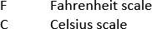 / Not Applicable ? Unknown

ADDITIONAL INFORMATION:
- If this field is left blank or marked Unknown, the actual patient temperature is considered missing by NTDS.
- NTDS only accepts temperature results on the Celsius scale. The V5 software converts Fahrenheit temperatures to Celsius for upload to NTDB.

DATA SOURCE:
ER nursing notes, Trauma Nurse Flowsheet, ER MD documentation, History & Physical (H&P), patient assessment forms

ED/Resus: Temperature Route

TAB NAME: ED/Resus, Initial Assessment ALLOW N/A? YES

REQUIRED? YES

ALLOW UNK? YES

REP WRITER NAME: EDAS_TEMP_R_AS_TEXT
To read answer as text,
add “_AS_TEXT”, otherwise field info returns as a number

DEFINITION:
Body area used to measure temperature. V5 options:
Oral Tympanic Rectal Axillary Core Other Temporal
Not Applicable Unknown

ADDITIONAL INFORMATION:

DATA SOURCE:
ER nursing notes, Trauma Nurse Flowsheet, ER MD documentation, History & Physical (H&P), patient assessment forms

ED/Resus: Initial Vitals- BMI

TAB NAME: ED/RESUS: Arrival/Admission REQUIRED? YES

ALLOW N/A? NO ALLOW UNK? YES

V5 REP WRITER NAME:EDAS_BMI_C

DEFINITION:

BMI is a person's weight in kilograms (kg) divided by his or her height in meters.

V5 OPTIONS:
N/A

ADDITIONAL INFORMATION:
  - Auto calculates based on documented height and weight.

DATA SOURCE:
ER nursing notes, ER MD documentation, Trauma/ED Flowsheet, Admission record, Anesthesia records, Nursing notes

ED/Resus: Intubation Method

TAB NAME: ALLOW N/A?

ED/Resus, Initial Assessment

YES

REQUIRED? YES

ALLOW UNK? YES

REP WRITER NAME: EDAS_INTUB_M01_AS_TEXT
Intubation Method
To read answer as text, add “_AS_TEXT”
Otherwise, field info returns as a number

DEFINITION:
If the patient was intubated, what method was used? Answer choices include:
Combitube Cricothyrotomy Cricothyrotomy-Needle Endotracheal Tube-Nasal Endotracheal Tube- Oral
Endotracheal Tube - Route NFS Esophageal Obturator Airway Laryngeal Mask Airway
LT Blind Insertion Airway Device Tracheostomy
Unknown

ADDITIONAL INFORMATION:
- Report the Intubation Method that coincides with the Initial ED/Hospital vital signs.

DATA SOURCE:
ER nursing notes, Trauma Nurse Flowsheet, ER MD documentation, History & Physical (H&P), Patient assessment forms, EMS PCR, Respiratory Therapy documentation

ED/Resus: Respiratory Assist Method

TAB NAME: ALLOW N/A?

ED/Resus, Initial Assessment

YES

REQUIRED? YES

ALLOW UNK? YES

REP WRITER NAME: EDAS_ARR_TYPE_AS_TEXT
To read answer as text, add “_AS_TEXT”
otherwise, field info returns as a number

DEFINITION:
Respiratory Assistance Method used to effectively provide air (oxygen) to the lungs and assist with breathing. Answer choices include:
Bag Valve Mask Nasal Airway Oral Airway Ventilator Unknown

ADDITIONAL INFORMATION:
- Report the Respiratory Assistance Method that coincides with the Initial ED/Hospital Respiratory Rate.

DATA SOURCE:
ER nursing notes, Trauma Nurse Flowsheet, ER MD documentation, History & Physical (H&P), Patient assessment forms, EMS PCR, Respiratory Therapy documentation

ED/Resus: Diastolic Blood Pressure (DBP)

TAB NAME:

ED/Resus, Initial Assessment
REQUIRED? YES

ALLOW N/A? YES

REP WRITER NAME: EDAS_DBP
ALLOW UNK? YES

DEFINITION:
Recorded diastolic blood pressure measured on admission.

ADDITIONAL INFORMATION:
- Report first Diastolic Blood Pressure recorded within 30 minutes upon arrival to your hospital.
DRAF
- Diastolic Blood Pressure is the bottom/second number when blood pressure is recorded.
- A normal diastolic blood pressure is < 80 but can often be much higher.

DATA SOURCE:
ER nursing notes, Trauma Nurse Flowsheet, ER MD documentation, History & Physical (H&P), Patient assessment forms, Vital Signs flowsheet

ED/Resus: Initial Vitals- RTS

TAB NAME: ED/RESUS: Arrival/Admission REQUIRED? YES

ALLOW N/A? NO ALLOW UNK? YES

V5 REP WRITER NAME: EDAS_RTS_W

DEFINITION:

The Revised Trauma Score based on vitals measured at the scene of injury. Consists of Glasgow Coma Scale, Systolic Blood Pressure and Respiratory Rate.

V5 OPTIONS:
N/A

ADDITIONAL INFORMATION:
  - Auto calculates based on documented GCS, SBP, and RR.

DATA SOURCE:
ER nursing notes, ER MD documentation, Trauma/ED Flowsheet, Admission record, Anesthesia records, Nursing notes

ED/Resus: Initial Vitals- Triage RTS

TAB NAME: ED/RESUS: Arrival/Admission REQUIRED? YES

ALLOW N/A? NO ALLOW UNK? YES

V5 REP WRITER NAME: EDAS_RTS_U

DEFINITION:

The Revised Trauma Score based on vitals measured at the scene of injury. Consists of Glasgow Coma Scale, Systolic Blood Pressure and Respiratory Rate.

V5 OPTIONS:
N/A

ADDITIONAL INFORMATION:
- Auto calculates based on documented GCS, SBP, and RR.

DATA SOURCE:
ER nursing notes, ER MD documentation, Trauma/ED Flowsheet, Admission record, Anesthesia records, Nursing notes

ED/Resus: Pediatric Trauma Score - Weight

TAB NAME: ED/RESUS: Initial Assessment REQUIRED? NO

ALLOW N/A? YES ALLOW UNK? YES

V5 REP WRITER NAME: EDAS_PTS_WT

DEFINITION:
Pediatric Trauma Score for Weight component measured at the scene of injury.

V5 OPTIONS:

2.Greater than 20kg (44 lbs)
- Between 10kg and 20kg (22-44 ibs)
-1 Less than 10kg (22 lbs)
/ Not Applicable
? Unknown

ADDITIONAL INFORMATION:
  - None

DATA SOURCE:
ER nursing notes, ER MD documentation, Trauma/ED Flowsheet, Admission record,

ED/Resus: Pediatric Trauma Score - Airway

TAB NAME: ED/RESUS: Initial Assessment REQUIRED? NO

ALLOW N/A? YES ALLOW UNK? YES

V5 REP WRITER NAME: EDAS_PTS_AIR

DEFINITION:
Pediatric Trauma Score for Airway component measured at the scene of injury.

V5 OPTIONS:
- Normal 1.Maintainable
-1 Unmaintainable or Intubated
/ Not Applicable
? Unknown

ADDITIONAL INFORMATION:

DATA SOURCE:
ER nursing notes, ER MD documentation, Trauma/ED Flowsheet, Admission record

ED/Resus: Pediatric Trauma Score – Cutaneous

TAB NAME: ED/RESUS: Initial Assessment REQUIRED? NO

ALLOW N/A? YES ALLOW UNK? YES

V5 REP WRITER NAME: EDAS_PTS_CUT

DEFINITION:
Pediatric Trauma Score for Cutaneous component measured at the scene of injury.

V5 OPTIONS:
2.No open wounds
- Minor open wounds
-1 Major or penetrating open wounds
/ Not Applicable
? Unknown

ADDITIONAL INFORMATION:

DATA SOURCE:
ER nursing notes, ER MD documentation, Trauma/ED Flowsheet, Admission record,

ED/Resus: Pediatric Trauma Score – CNS

TAB NAME: | ED/RESUS: Initial Assessment | REQUIRED? NO
ALLOW N/A? | YES | ALLOW UNK? YES

V5 REP WRITER NAME: EDAS_PTS_CNS

DEFINITION:
Pediatric Trauma Score for CNS component measured at the scene of injury.

V5 OPTIONS:
2.Awake
- Altered mental status or obtunded
-1 Coma or Abnormal Flexion
/ Not Applicable
? Unknown

ADDITIONAL INFORMATION:

DATA SOURCE:
ER nursing notes, ER MD documentation, Trauma/ED Flowsheet, Admission record,

ED/Resus: Pediatric Trauma Score – Pulse Palp

TAB NAME: ED/RESUS: Initial Assessment REQUIRED? NO

ALLOW N/A? YES ALLOW UNK? YES

V5 REP WRITER NAME: EDAS_PTS_PLP

DEFINITION:
Pediatric Trauma Score for Pulse Palp component measured at the scene of injury

V5 OPTIONS:
- Pulse palpable at wrist (SBP over 90 mmHg)
- Pulse palpable at groin (SBP btwn 50 and 90 mmHg)
-1 Coma or Abnormal Flexion
/ Not Applicable
? Unknown

ADDITIONAL INFORMATION:

DATA SOURCE:
ER nursing notes, ER MD documentation, Trauma/ED Flowsheet, Admission record,

ED/Resus: Pediatric Trauma Score – Total

TAB NAME: ED/RESUS: Initial Assessment REQUIRED? NO

ALLOW N/A? YES ALLOW UNK? YES

V5 REP WRITER NAME: EDAS_PTS_PTS

DEFINITION:
The total Pediatric Trauma Score measured at the scene of injury.

V5 OPTIONS:
N/A

ADDITIONAL INFORMATION:
- Auto-calculates based on pediatric trauma score components

DATA SOURCE:
ER nursing notes, ER MD documentation, Trauma/ED Flowsheet, Admission record,

ED/Resus: ABGs Drawn

TAB NAME: ED/RESUS: Labs/Toxicology REQUIRED? NO

ALLOW N/A? YES ALLOW UNK? YES

V5 REP WRITER NAME: ED_ABG_DRAWN

DEFINITION:
Was arterial blood gas (ABG) tested?

V5 OPTIONS:
Yes No
/ Not Applicable
? Unknown

ADDITIONAL INFORMATION:
  - First ABG result. Must be in first 24 hours after patient arrival.

DATA SOURCE:
ER nursing notes, ER MD documentation, Trauma/ED Flowsheet, Lab results

ED/Resus: pH

TAB NAME: ED/RESUS: Labs/Toxicology REQUIRED? NO

ALLOW N/A? YES ALLOW UNK? YES

V5 REP WRITER NAME: ED_ABG_PH

DEFINITION:
Potential hydrogen, a scale representing the relative acidity (or alkalinity) in your blood.

V5 OPTIONS:
N/A

ADDITIONAL INFORMATION:
- Number recorded as whole number with decimal point.

DATA SOURCE:
ER nursing notes, ER MD documentation, Trauma/ED Flowsheet, Lab results

ED/Resus: PaO2

TAB NAME: ED/RESUS: Labs/Toxicology REQUIRED? NO

ALLOW N/A? YES ALLOW UNK? YES

V5 REP WRITER NAME: ED_ABG_PAO2

DEFINITION:
The partial pressure of oxygen, also known as PaO2, is a measurement of oxygen pressure in arterial blood.

V5 OPTIONS:
N/A

ADDITIONAL INFORMATION:
- Number recorded as whole number

DATA SOURCE:
ER nursing notes, ER MD documentation, Trauma/ED Flowsheet, Lab results

ED/Resus: PaCO2

TAB NAME: ED/RESUS: Labs/Toxicology ALLOW N/A? YES

V5 REP WRITER NAME: ED_ABG_PACO2

DEFINITION:
Partial pressure of carbon dioxide in arterial blood.

V5 OPTIONS:
N/A

ADDITIONAL INFORMATION:
Number recorded as whole number
REQUIRED? NO

ALLOW UNK? YES

DATA SOURCE:
ER nursing notes, ER MD documentation, Trauma/ED Flowsheet, Lab results

ED/Resus: Hematocrit

TAB NAME: | ED/RESUS: Labs/Toxicology | REQUIRED? NO
ALLOW N/A? | YES | ALLOW UNK? YES

V5 REP WRITER NAME: ED_LAB_HCT

DEFINITION:

The patient’s initial hematocrit value obtained at your facility drawn within 30 minutes of patient arrival.

V5 OPTIONS:
N/A

ADDITIONAL INFORMATION:

- None

DATA SOURCE:
ER nursing notes, ER MD documentation, Trauma/ED Flowsheet, Lab results

ED/Resus: INR

TAB NAME: ED/RESUS: Labs/Toxicology REQUIRED? NO

ALLOW N/A? YES ALLOW UNK? YES

V5 REP WRITER NAME: ED_LAB_INR

DEFINITION:
The international normalized ratio (INR) is a laboratory measurement of how long it takes blood to form a clot.

V5 OPTIONS:
N/A

ADDITIONAL INFORMATION:

None

DATA SOURCE:
ER nursing notes, ER MD documentation, Trauma/ED Flowsheet, Lab results

ED/Resus: Base Deficit

TAB NAME:

ED/Resus/Initial Assessment/ED Vitals

REQUIRED? YES

ALLOW N/A? YES ALLOW UNK? YES

REP WRITER NAME: ED_ABG_BASE

DEFINITION:
This number is reported as a component of arterial or venous blood gasses. The number may be reported by the lab as Base Deficit, or as Base Excess with a negative value.

ADDITIONAL INFORMATION:
- First recorded Base Excess/Base Deficit within 24 hours of arrival to index hospital.
- Base Deficit - Arterial blood gas component showing the degree of acid/base imbalance with a normal range being +/- 2 Meq./L. A valid Base Deficit value range is +/- 80.
- -81 = Not Available
- -83 = Pending

DATA SOURCE:
Laboratory results, ER nursing notes, Trauma Nurse Flowsheet, ER MD documentation, History & Physical (H&P), Patient assessment forms, Vital Signs flowsheet

ED/Resus: Drug Use Indicators

TAB NAME: ALLOW N/A?

ED/Resus, Initial Assessment

YES

REQUIRED? YES

ALLOW UNK? YES

REP WRITER NAME:
ED_IND_DRG01_AS_TEXT Drug Use Indicator01 ED_IND_DRG02_AS_TEXT Drug Use Indicator02
To read answer as text, add “_AS_TEXT”, otherwise field info returns as a number

DEFINITION:
Was the patient tested for drug use at outside facility OR your facility? Answer choices include:
No (Not Tested)
No (Confirmed by Test)
Yes (Confirmed by Test [Prescription Drug]) Yes (Confirmed by Test [Illegal Use Drug])
Yes (Confirmed by Test [Unknown if Prescribed or Illegal]) Not Applicable
Unknown

ADDITIONAL INFORMATION:
- More than one answer may be needed if the patient tested positive for prescription and illegal drug use.
- Information from a referring facility may be used.

DATA SOURCE:
Lab results, ER nursing notes, ER MD documentation, History & Physical (H&P), Consult note, Outside facility documentation

ED/Resus: CPR

TAB NAME: ALLOW N/A?

ED/Resus, Vitals

YES

REQUIRED? YES

ALLOW UNK? YES

REP WRITER NAME: ED_CPR_AS_TEXT
To read answer as text,
add “_AS_TEXT”, otherwise field info returns as a number

DEFINITION:
Was CPR initiated in the ED by hospital personnel?

Not Performed Performed
Not Applicable Unknown

ADDITIONAL INFORMATION:
- If patient is a Direct Admit, answer should be Not Applicable.

Excludes CPR initiated by EMS.
- If the patient had CPR in progress on arrival and the patient had return of spontaneous circulation (ROSC) and then had to have CPR re-initiated, the field value will be Performed.

DATA SOURCE:
Trauma Nurse Flowsheet, Code sheet, ER nursing notes, ER MD documentation, History & Physical (H&P), Consult note

ED/Resus: Mass Blood Protocol

TAB NAME: ALLOW N/A?

ED/Resus, Vitals

YES

REQUIRED? YES

ALLOW UNK? YES

REP WRITER NAME: ED_MBP_YN_AS_TEXT
To read answer as text,
add “_AS_TEXT”, otherwise field info returns as a number

DEFINITION:
Was Massive Blood Protocol (MBP) or Massive Transfusion Protocol (MTP) activated in the first 4 hours after patient arrival?
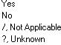

ADDITIONAL INFORMATION:
- Applies to all patients.
- If MBP or MTP not used in first 4 hours of patient arrival, answer NO.
- Protocol use is not dependent on the patient location as long as protocol activated in first 4 hours after arrival.

DATA SOURCE:
Trauma Nursing Flowsheet, ER nursing notes, ER MD documentation, History & Physical (H&P), Lab and/or Blood Bank documentation

ED/Resus: Mass Blood Protocol Date/Time

TAB NAME: ALLOW N/A?
REP WRITER NAME: ED_MBP_DATE ED_MBP_TIME ED_MBP_EVENT

ED/Resus, Vitals

YES

Mass Blood Protocol Date Mass Blood Protocol Time
Mass Blood Protocol Date/Time

REQUIRED? YES

ALLOW UNK? YES

DEFINITION:
Date and time the Massive Blood Protocol was activated (ordered).

ADDITIONAL INFORMATION:
- Record answer MM/DD/YYYY for date and HH:MM (military) for time.
- If activated (ordered), enter date and time even if blood was not administered i.e., patient died.
- Date and time protocol started is not dependent on the patient location as long as protocol activated in first 4 hours after arrival.

DATA SOURCE:
Trauma Nursing Flowsheet, ER nursing notes, ER MD documentation, History & Physical (H&P), Blood Bank documentation

ED/Resus: Mass Blood Protocol Administered

TAB NAME: ALLOW N/A?

ED/Resus, Vitals

YES

REQUIRED? YES

ALLOW UNK? YES

REP WRITER NAME:
ED_MBP_ADMIN_DATE Mass Blood Protocol Administration Date
ED_MBP_ADMIN_TIME Mass Blood Protocol Administration Time
ED_MBP_ADMIN_EVENT Mass Blood Protocol Administration Date/Time

DEFINITION:
Date and time the first blood product administered for Massive Blood Protocol.

ADDITIONAL INFORMATION:
- Record answer MM/DD/YYYY for date and HH:MM (military) for time.
- Date and time blood product administration is not dependent on the patient location as long as protocol activated in first 4 hours after arrival.
- If activated (ordered) but blood was not administered i.e., patient died, enter N/A.

DATA SOURCE:
Trauma Nursing Flowsheet, ER nursing notes, ER MD documentation, History & Physical (H&P), Blood Bank documentation

Patient Tracking: Stepdown/IMC Days

TAB NAME: Patient Tracking: Location/Service REQUIRED? NO

ALLOW N/A? YES ALLOW UNK? YES

V5 REP WRITER NAME: STEP_DAYS

DEFINITION:
Stepdown/IMC Days length of stay

V5 OPTIONS:
N/A

ADDITIONAL INFORMATION:

  - None

DATA SOURCE:
Nursing notes, Physician Progress Notes, Hospital Bed Tracking

Patient Tracking: Blood Product

TAB NAME: Patient Tracking: Ventilator/Blood REQUIRED? NO

ALLOW N/A? YES ALLOW UNK? YES

V5 REP WRITER NAME: BLOOD_TYPES_L_AS_TEXT

DEFINITION:
The type of blood product given to the patient during the initial visit at your facility.

V5 OPTIONS:

Packed Red Blood Cells Plasma
Platelets
Other Blood Substitute Cryoprecipitate Normal Saline 0.9% Hartmans
Hypertonic 0.9 Normal Saline + Glucose Saline 3%
Crystalloids Whole Blood
/ Not Applicable
? Unknown

ADDITIONAL INFORMATION:
- None

DATA SOURCE:
Nursing notes, Lab documentation, Intake documentation

Patient Tracking: Volume

TAB NAME: Patient Tracking: Ventilator/Blood REQUIRED? NO

ALLOW N/A? YES ALLOW UNK? YES

V5 REP WRITER NAME: BLOOD_UNITS_L

DEFINITION:
The total number of units given per event to the patient within the first 24 hours

V5 OPTIONS:
N/A

ADDITIONAL INFORMATION:

- None

DATA SOURCE:
Nursing notes, Lab documentation, Intake documentation

Patient Tracking: Units

TAB NAME: Patient Tracking: Ventilator/Blood REQUIRED? NO

ALLOW N/A? YES ALLOW UNK? YES

V5 REP WRITER NAME: BLOOD_UNITS_MEASS_L_AS_TEXT

DEFINITION:
The unit of measure of the product per event within the first 24 hours.

V5 OPTIONS:
L
mL Units
Not Applicable Unknown

ADDITIONAL INFORMATION:

- None

DATA SOURCE:
Nursing notes, Lab documentation, Intake documentation

Patient Tracking: Location

TAB NAME: Patient Tracking: Ventilator/Blood REQUIRED? NO

ALLOW N/A? YES ALLOW UNK? YES

V5 REP WRITER NAME: BLOOD_LOCS_L_AS_TEXT

DEFINITION:
The location blood products given.

V5 OPTIONS:
Resuscitation Room Emergency Department Operating Room Intensive Care Unit
Step Down Unit Floor Telemetry Unit
Observation Unit Burn Unit Radiology

ADDITIONAL INFORMATION:

- None

Post Anesthesia Care Unit Special Procedure Unit
Labor and Delivery Neonatal/Pediatric Care Unit Prehospital
Referring Facility
/ Not Applicable
? Unknown

DATA SOURCE:
Nursing notes, Lab documentation, Intake documentation

Patient Tracking: Time Period

TAB NAME: Patient Tracking: Ventilator/Blood REQUIRED? NO

ALLOW N/A? YES ALLOW UNK? YES

V5 REP WRITER NAME: BLOOD_TIME_PDS_L_AS_TEXT

DEFINITION:
The time range during which the blood products were given per event within the 1st 24 hours.

V5 OPTIONS:
Prior to Facility Arrival
First 4 hours after facility arrival
Between 4 and 24 hours after facility arrival Between 24 and 48 hours after facility arrival More than 48 hours after facility arrival
/ Not applicable
? Unknown

ADDITIONAL INFORMATION:
- None

DATA SOURCE:
Nursing notes, Lab documentation, Intake documentation

Providers/Resus Team: Trauma Provider Specialty

TAB NAME: ALLOW N/A?

Providers, Resus Team

YES

REQUIRED? YES

ALLOW UNK? YES

REP WRITER NAME:
EDP_TYPE01_AS_TEXT Trauma Provider Specialty # EDP_MD_LNK01 Trauma Provider ID #
To read answer as text, add “_AS_TEXT”, otherwise field info returns as a number

DEFINITION:
The physician/provider specialty delivering trauma care in any level of team activation.

ADDITIONAL INFORMATION:
- Only Trauma specialty information is required. Check with your Trauma Program Manager if the name of the Trauma Physician should also be included. Usually, the physician’s name is collected by the facility for program reporting purposes.
- If teaching facility, enter Attending Physician’s name/number.
- If patient has response level answer, 4 No Response, the trauma provider # and name should be Not Applicable.
- If the physician’s name is included, it is not downloaded by the state.
- Provider consults for Emergency Medicine, Anesthesiology, Neurosurgery, Orthopedics may be entered on this tab or the In-House Consults tab (at the discretion of each facility).

DATA SOURCE:
Trauma Nursing Flowsheet, ER nursing notes, ER MD documentation, History & Physical (H&P)

Providers/Resus Team: Trauma Called Date/Time

TAB NAME: Providers: Resus Team REQUIRED? NO

ALLOW N/A? YES ALLOW UNK? YES

V5 REP WRITER NAME: EDP_C_EVENT01
*Change # to correspond with provider

DEFINITION:
The date the Trauma Provider was notified of trauma activation.

V5 OPTIONS:
N/A

ADDITIONAL INFORMATION:
  - Record answer MM/DD/YYYY for date and HH:MM (military) for time.

DATA SOURCE:
Nursing notes, Trauma Flowsheet, EMR, Physician Notes

Providers/Resus Team: Trauma Arrived Date/Time

TAB NAME:

SEND TO NTDB?

Providers, Resus Team

YES, 2022 NTDB DD

REQUIRED? YES

ALLOW UNK? YES

ALLOW N/A? YES

REP WRITER NAME: EDP_A_DATE01 Trauma Arrival Date
EDP_A_TIME01 Trauma Arrival Time EDP_A_EVENT01 Trauma Arrival Date/Time

DEFINITION:
First documented date and time Trauma Physician/Attending arrives at the patient bedside for team activation.

ADDITIONAL INFORMATION:
- Record answer MM/DD/YYYY for date and HH:MM (military) for time.
- Response time is for the Trauma/General Surgeon or Emergency Physician(Level IVs) providing care/ oversight of team resuscitation.
- For Level 1 and 2 trauma centers, the maximum acceptable response time for the highest activation level is 15 minutes. Response time is tracked from patient arrival
- For Level III and Level IV trauma centers, the maximum acceptable response time for the highest activation level is 30 minutes. Response time is tracked from patient arrival
- An 80 percent attendance threshold must be met for the highest-level activations (CD 2–8).

DATA SOURCE:
Trauma Nursing Flowsheet, ER nursing notes, ER MD documentation, History & Physical (H&P), Consult note

Providers/Resus Team: Provider Type

TAB NAME: Providers: Resus Team REQUIRED? NO

ALLOW N/A? YES ALLOW UNK? YES

V5 REP WRITER NAME: EDP_TYPE01_AS_TEXT
*change number to correspond with provider
DEFINITION:
Resus Team Provider Type Service.

V5 OPTIONS:

Trauma Internal Medicine Respiratory Therapist Surgical ICU

Neurosurgery Intensivist Social Worker Wound Care/Soft Tissue

Orthopedics Nephrology Speech Therapy Other Surgical

General Surgery Neurology Thoracic Surgery Other Non-Surgical

Pediatric Surgery Nursing Trauma Resuscitation Nurse ? Unknown

Cardiothoracic Surgery Nutrition Triage Nurse

Burn Services OB-GYN Urology

Emergency Medicine Occupational Therapy Vascular Surgery

Pediatrics Ophthalmology Interventional Radiology

Anesthesiology Oral Surgery Advanced Practice Provider

Cardiology Oral Maxillofacial Surgery CCA

Critical Care Ortho-spine CRNA

Documentation Recorder Physician Assistant Craniofacial

ENT Physiatry Emergency Airway Team

Family Medicine Plastic Surgery Emergency Airway Team Lead

GI Pulmonary Mental Health

Hospitalist Psychiatry Otolaryngology

Infectious Disease Radiology Pain Management

Nurse Practitioner Rehab Scribe

ADDITIONAL INFORMATION:
  - Other types of providers that respond to trauma activations beside Trauma, Ortho, Neurosurgery, Anesthesiology, Emergency Medicine

DATA SOURCE:
Nursing notes, Trauma Flowsheet, EMR, Physician Notes

Providers/Resus Team: Provider Called Date/Time

TAB NAME: Providers: Resus Team REQUIRED? NO

ALLOW N/A? YES ALLOW UNK? YES

V5 REP WRITER NAME: EDP_C_EVENT0#
*use # that corresponds to provider recorded in registry

DEFINITION:
The date and time the Provider was notified of trauma activation.

V5 OPTIONS:

N/A

ADDITIONAL INFORMATION:

- Other types of providers that respond to trauma activations beside Trauma, Ortho, Neurosurgery, Anesthesiology, Emergency Medicine

DATA SOURCE:
Nursing notes, Trauma Flowsheet, EMR, Physician Notes

Providers/Resus Team: Provider Responded Date/Time

TAB NAME: Providers: Resus Team REQUIRED? NO

ALLOW N/A? YES ALLOW UNK? YES

V5 REP WRITER NAME: EDP_R_EVENT0#
*use # that corresponds with provider recorded in registry

DEFINITION:
Resus Team Provider Responded Date and Time.

V5 OPTIONS:

N/A

ADDITIONAL INFORMATION:

- Other types of providers that respond to trauma activations beside Trauma, Ortho, Neurosurgery, Anesthesiology, Emergency Medicine

DATA SOURCE:
Nursing notes, Trauma Flowsheet, EMR, Physician Notes

Providers/Resus Team: Provider Arrived Date/Time

TAB NAME: Providers: Resus Team REQUIRED? NO

ALLOW N/A? YES ALLOW UNK? YES

V5 REP WRITER NAME: EDP_A_EVENT0#
*use number that corresponds with provider in registry

DEFINITION:
The date and time the Provider arrived at the patient’s bedside.

V5 OPTIONS:

N/A

ADDITIONAL INFORMATION:

- Other types of providers that respond to trauma activations beside Trauma, Ortho, Neurosurgery, Anesthesiology, Emergency Medicine

DATA SOURCE:
Nursing notes, Trauma Flowsheet, EMR, Physician Notes

Providers/Resus Team: Provider Timeliness

TAB NAME: Providers: Resus Team ALLOW N/A? YES

V5 REP WRITER NAME: EDP_TMLY01. *use number that corresponds to provider in registry

DEFINITION:
The timeliness of the Provider's arrival at the patient’s bedside.

V5 OPTIONS:
REQUIRED? NO

ALLOW UNK? YES

Timely
Not Timely Absent
Not Applicable Unknown

ADDITIONAL INFORMATION:

- Other types of providers that respond to trauma activations beside Trauma, Ortho, Neurosurgery, Anesthesiology, Emergency Medicine

DATA SOURCE:
Nursing notes, Trauma Flowsheet, EMR, Physician Notes

Providers/Resus Team: Provider Elapsed Time

TAB NAME: Providers: Resus Team REQUIRED? NO

ALLOW N/A? YES ALLOW UNK? YES

V5 REP WRITER NAME: EDP_ELAPSED01

DEFINITION:
The timeliness of the Provider's arrival at the patient’s bedside.

V5 OPTIONS:

N/A

ADDITIONAL INFORMATION:

- Other types of providers that respond to trauma activations beside Trauma, Ortho, Neurosurgery, Anesthesiology, Emergency Medicine

DATA SOURCE:
Nursing notes, Trauma Flowsheet, EMR, Physician Notes

Providers: In-House Consults: Type (part 1 of 2)

TAB NAME: ALLOW N/A?

Providers, In-House Consults
YES
REQUIRED? YES
ALLOW UNK? YES

REP WRITER NAME:
A_CS_TYPE_AS_TEXT Consult Specialty as text CS_MD_LNKS List of all Consults as ID Link CS_MD_LNKS_AS_TEXT List of all Consultants as text
To read answer as text, add “_AS_TEXT”, otherwise field info returns as a number

DEFINITION:
Providers giving recommendations and/or care to a trauma patient during hospitalization.

Note: Capture of in-house consults for trauma, neurosurgery, orthopedics and interventional radiology are essential for documenting ACS standards and are required when appropriate.

V5 Options:

Trauma Neurosurgery Orthopedics General Surgery Pediatric Surgery
Cardiothoracic Surgery
Burn Services
Emergency Medicine Pediatrics
Anesthesiology
Cardiology
Chaplain
Child Protective Team Critical Care
Discharge Planner
Documentation Recorder Drug/Alcohol Counselor ENT
Family Medicine GI
Home Health
Hospitalist
Infectious Disease

Internal Medicine
Laboratory
Nephrology
Neurology
Nurse Practitioner
Nursing
Nutrition
Ob-Gyn
Occupational Therapy
Oncology Ophthalmology Oral Surgery
Oral Maxillofacial Surgery Ortho-Spine
Palliative Care Pharmacy Physiatry
Physical Therapy Plastic Surgery Psychiatry Pulmonary Radiology
Rehab
Respiratory Therapist Social Services
Social Worker
Speech Therapy

Thoracic Surgery
Trauma Resuscitation Nurse Triage Nurse
Urology Vascular Surgery Intensivist
Physician Assistant Endocrinology Geriatrics
Hand Surgery
Interventional Radiology Other Surgical
Other Non-Surgical
Not Applicable Unknown
Advanced Practice Provider CCA
Craniofacial CRNA
Emergency Airway Team Emergency Airway Team Lead Mental Health Otolaryngology
Pain Management Scribe
Surgical ICU
Wound Care/Soft Tissue

Providers: In-House Consults: Type (part 2 of 2)

ADDITIONAL INFORMATION:
- Essential specialties listed have Performance Improvement and Patient Safety (PIPS) metrics for response timeliness, therefore only 4 specialties are listed.
- All other non-essential specialties are collected at the discretion of each facility.
- If there is no trauma team activation but there is a trauma consult, enter Trauma consult information in this field.
- Only the consultant specialty is required. Check with your Trauma Program Manager if the name of the consultant should also be included.
- Do not list two consultants from the same specialty. Due to call coverage, often several providers from the
same specialty may see the patient to maintain 24/7 coverage during the patient’s stay.
- Provider consults for Emergency Medicine, Anesthesiology, Neurosurgery, Orthopedics may be entered on this tab or on the Resus Team tab (at the discretion of each facility).

DATA SOURCE:
Consult notes, Procedure notes, Operative Reports, MD documentation, History & Physical (H&P), Trauma flowsheet, EMR

Providers/Consults: Called Date

TAB NAME: Providers: In-House Consults ALLOW N/A? YES

V5 REP WRITER NAME: CS_C_EVENT01

DEFINITION:
The date the consulting service was notified.

V5 OPTIONS:

N/A

ADDITIONAL INFORMATION:

  - In-house consults not collected in resus team.

DATA SOURCE:
Nursing notes, Consult notes, Progress Notes, EMR
REQUIRED? NO

ALLOW UNK? YES

Providers/Consults: Arrived Date

TAB NAME: Providers: In-House Consults REQUIRED? NO

ALLOW N/A? YES ALLOW UNK? YES

V5 REP WRITER NAME: CS_EVENT01

DEFINITION:
The earliest (first) date and time the consulting service saw the patient

V5 OPTIONS:

N/A

ADDITIONAL INFORMATION:

- In-house consults not collected in resus team.

DATA SOURCE:
Nursing notes, Consult Notes, Progress Notes, EMR

Providers/Consults: Timeliness

TAB NAME: Providers: In-House Consults REQUIRED? NO

ALLOW N/A? YES ALLOW UNK? YES

V5 REP WRITER NAME: CS_TMLY01

DEFINITION:
In-house Consults Provider Timeliness.

V5 OPTIONS:

Timely
Not Timely Absent
/ Not Applicable
? Unknown

ADDITIONAL INFORMATION:

- In-house consults not collected in resus team.

DATA SOURCE:
Nursing notes, Consult Notes, Progress Notes, EMR

Procedures: Location Code & Description

TAB NAME: Procedures, ICD 10

ALLOW N/A? NO

REP WRITER NAME: A_PR_LOC_AS_TEXT
To read answer as text, add “_AS_TEXT”
otherwise, field info returns as a number
REQUIRED? YES

ALLOW UNK? NO

DEFINITION:
Patient location where procedure performed. Procedures performed in the ED, OR and ICU are essential. V5 options:
Emergency Department
Operating Room Intensive Care Unit Step-Down Unit Floor
Observation Unit Burn Unit Radiology
Post Anesthesia Care Unit Special Procedure Unit Labor and Delivery Neonatal/Pediatric Care Unit Interventional Radiology Computed Tomography(CT) Point of Care Ultrasound
Magnetic Resonance Imaging(MRI)

ADDITIONAL INFORMATION:
- If procedure is performed in the Interventional Radiology Procedures area of Radiology, choose the answer Radiology.
- If the procedure was performed in a special procedure unit such as Endoscopy, Vascular Lab, Hyperbaric chamber, etc., chose Specialty.
- Check with your TPM on areas that fall into the category Special Procedure Unit.

DATA SOURCE:
ER nursing notes, ER MD documentation, History & Physical (H&P), Consult note, Operative reports, Procedure notes, ICU notes

Procedures: Operation #

TAB NAME: | Procedures | REQUIRED? NO
ALLOW N/A? | YES | ALLOW UNK? YES

V5 REP WRITER NAME: PR_OP_NUMS_L

DEFINITION:
A sequential number given to each visit to the operating room.

V5 OPTIONS:

N/A

ADDITIONAL INFORMATION:

  - None

DATA SOURCE:
OR notes, Anesthesia records, EMR

Procedures: Stop Date and Time

TAB NAME: Procedures REQUIRED? NO

ALLOW N/A? YES ALLOW UNK? YES

V5 REP WRITER NAME: PR_STP_EVENTS_L

DEFINITION:
The date the operative and selected non-operative procedures were completed.

V5 OPTIONS:

N/A

ADDITIONAL INFORMATION:

- None

DATA SOURCE:
OR notes, Anesthesia records, EMR

Diagnosis: NISS
TAB NAME: Diagnosis: Injury Coding REQUIRED? YES

ALLOW N/A? NO ALLOW UNK? YES

V5 REP WRITER NAME: NISS

DEFINITION:
The New Injury Severity Score is the sum of the squares of the three highest AIS in any ISS body region. This score is used as a predictor of mortality.

V5 OPTIONS:

N/A

ADDITIONAL INFORMATION:

- Auto-calculated

DATA SOURCE:
N/A

Diagnosis: TRISS

TAB NAME: Diagnosis: Injury Coding REQUIRED? YES

ALLOW N/A? NO ALLOW UNK? YES

V5 REP WRITER NAME: TRISS

DEFINITION:
Trauma and Injury Severity Score determines the probability of survival of a patient. TRISS is based upon the ISS, RTS (Revised Trauma Score), age, and injury type (blunt/penetrating).

V5 OPTIONS:

N/A

ADDITIONAL INFORMATION:

- Auto-calculated

DATA SOURCE:
N/A

Outcome: Discharge Status

TAB NAME: ALLOW N/A?

Outcome, Initial Discharge

NO

REQUIRED? YES

ALLOW UNK? NO

REP WRITER NAME: DIS_STATUS_AS_TEXT
To read answer as text, add “_AS_TEXT”,
otherwise, field info returns as a number

DEFINITION:
Patient status at end of hospital visit. Answer choices include:
Alive Dead

ADDITIONAL INFORMATION:
- Mark according to patient outcome regardless of death location.
- Do not use n/a or unknown.
- For brain death, enter Dead.

DATA SOURCE:
Discharge/death records, Nursing notes, MD documentation, History & Physical (H&P), Consult note, ADT/ Hospital Timestamp

Initial Discharge: Patient Directive Applied

TAB NAME: | Outcomes: Initial Discharge | REQUIRED? NO
ALLOW N/A? | YES | ALLOW UNK? YES

V5 REP WRITER NAME: CARE_DIRECTIVE

DEFINITION:
A legal document in which a person specifies what actions should be taken for their health if they are no longer able to make decisions for themselves because of illness or incapacity.

V5 OPTIONS:

Care Directive Applied Care Directive Not Applied No Care Directive Provided Not Applicable
Unknown

ADDITIONAL INFORMATION:
  - None

DATA SOURCE:
Palliative Care Notes, Physician Notes, Social Work Notes, Nursing Notes, EMR

Initial Discharge: Total Days; Hospital

TAB NAME: Outcomes: Initial Discharge ALLOW N/A? YES

V5 REP WRITER NAME: HOSP_DAYS

DEFINITION:
The total cumulative number of days the patient spent in your facility.

V5 OPTIONS:

N/A

ADDITIONAL INFORMATION:
- Auto-Calculated

DATA SOURCE:
N/A
REQUIRED? YES

ALLOW UNK? NO

Outcome: Discharged to Alternate Caregiver

TAB NAME: ALLOW N/A?

Outcome, Initial Discharge

YES
REQUIRED? YES

ALLOW UNK? YES

REP WRITER NAME: DIS_TO_ALT_CGVR_YN

DEFINITION:
This field is opened for completion if Report of Physical Abuse on Injury, Injury Information tab is answered YES. Answer choices include:
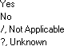

ADDITIONAL INFORMATION:
- Only report when Report of Physical Abuse is “Yes”.
- Only report for minors as determined by state/local definition, excluding emancipated minors.
- The null value "Not Applicable" should be reported for patients where Report of Physical Abuse is “No” or
were older than the state/local age definition of a minor.
- The null value “Not Applicable” should be reported if the patient expires prior to discharge.

DATA SOURCE:
Nursing notes, Discharge Planner notes, Discharge Summary, Social Work / Case Worker notes

Outcome: Hospital Disposition

TAB NAME: NTDB FIELD? ALLOW N/A?

Outcome, Initial Discharge
YES
YES, if ED discharge without orders
REQUIRED? YES

ALLOW UNK? NO

DEFINITION:
This field is a NTDS data required element. The disposition of the patient after hospital discharge. V5

options:

Discharged Home with No Home Services
Discharged/Transferred to Home Under Care of Organized Home Health Services
Left Against Medical Advice or Discontinued Care
Discharged/Transferred to Court/Law Enforcement
Expired
Discharged/Transferred to a Short-Term General Hospital for Inpatient Care
Discharged/Transferred to an Intermediate Care Facility (ICF)
Discharged/Transferred to Skilled Nursing Facility (SNF)
Discharged/Transferred to Inpatient Rehab or Designated Unit Discharged/Transferred to Long Term Care Hospital (LTCH)
Discharged/Transferred to Hospice Care
Discharged/Transferred to a Psychiatric Hospital or Distinct Part Unit of a Hospital
D. ischarged/Transferred to another Type of Institution not Defined Elsewhere
Burn Center
SCI Rehabilitation TBI Rehabilitation
Musculoskeletal Rehabilitation
Not Applicable

ADDITIONAL INFORMATION:
- Short-Term General Hospital for Inpatient Care: an acute care hospital capable of providing inpatient medical care with services for surgery, acute medical conditions, or injuries.
- Skilled Nursing Facility (SNF): a nursing facility with the staff and equipment to give skilled nursing care and/or skilled rehabilitation services and other related health services. A level of care that requires the daily involvement of skilled nursing or rehabilitation staff.
- Intermediate care facility (ICF): a long-term care facility that provides nursing and supportive care to residents on a non-continuous skilled nursing care basis and provide custodial care for those who are unable to care for themselves because of mental disability or declining health.
- For patients discharged from the ED without admit orders, report the null value “Not Applicable”.
- Will need to initially populate field for ED transfers in order to capture facility transferred to then go back and change to N/A - see Outcome:If Transferred, Facility
DATA SOURCE: Nursing notes, D/C summary, Consult note, Discharge planner notes

Outcome: If Transferred, Facility

TAB NAME: ALLOW N/A?

Outcome, Initial Discharge
YES

REQUIRED?

ALLOW UNK?
YES
Y
REP WRITER NAME: DIS_FAC_LINK_AS_TEXT
To read answer as text, add “_AS_TEXT”
otherwise, field info returns as a number

DEFINITION:
The name of the Intermediate Care facility, Acute Care hospital, Skilled Nursing facility (SNF), Inpatient Rehab, or Long-term Care facility where the patient is discharged.

ADDITIONAL INFORMATION:
- This data field is also used for patients transferred from the ED to another facility.
  - In the “Discharge To” field, choose “70. Discharged/Transferred to a Short-Term General Hospital for Inpatient Care”.
  - In the “If Transferred, Facility” field, start typing the name of the receiving facility to find the hospital the patient was transferred to. The state ID number will auto populate when a hospital name is chosen.
  - Go back to the “Discharge To” field and change it back to “Not Applicable”.
- Facilities are listed in the registry program. Start typing the name to find the correct facility. The state ID number will auto populate (if available) when a name is chosen.
- The null value “Not Applicable” is used only for patients who were not discharged to another facility.
- If you are unable to locate a Georgia facility in the pick list, please contact the State Trauma Registrar or Office of EMS Trauma at trauma@dph.ga.gov. If a facility is not available as a choice, use one of the following (as applies):

If facility name not available | Facility # | Facility Name
Georgia (not designated) | 10000 | Acute Care Hospital, Non-Desgd, Unsp (GA)
Georgia (designated trauma center) | 20000 | Acute Care Hospital, trauma hospital, Unsp (GA)
Georgia (not further specified) Georgia | 99999 | Georgia Hospital (unspecified)
Out of state: Alabama | 16000 | Alabama Hospital
Florida | 15000 | Florida Hospital
North Carolina | 13000 | NC Hospital
South Carolina | 19010 | SC Hospital
Tennessee | 19020 | Tennessee Hospital
Texas | 91900 | Texas Hospital
Other States | 17000 | Other state specified
Unspecified state | 40000 | Unspecified state
Air Force Hospital | 14010 | Moody
 | 14015 | Warner Robins
U.S. Naval Services | 14030 | U.S.N.S. Comfort
U.S. Penitentiary | 15090 | Penitentiary Hospital
U.S. Virgin Islands | 14040 | Virgin Islands Hospital
Other: Rehab Facility, Unspecified | 40000 | Rehab Facility, Unspecified
Intermediate Care Facility, Unspecified | 70000 | Intermediate Care Facility, Unspecified
Skilled Nursing Facility, Unspecified | 60000 | Skilled Nursing Facility, Unspecified
DATA SOURCE: Nursing notes, Discharge Summary, Discharge Orders, Discharge planner notes

Outcome: Discharged To- Specify

(Data field is currently a request from the Rehab Subcommittee)

TAB NAME: ALLOW N/A?

REP WRITER NAME:

Outcome, Initial Discharge
YES

DIS_DEST_S
REQUIRED? YES
ALLOW UNK? YES

DEFINITION:
The name of the facility the patient was discharged to, if choice is not available in the “If Transferred, Facility”
pick list.

ADDITIONAL INFORMATION:
- This is a free text field for facilities not listed in the “If Transferred, Facility” pick list.
- Applies to Skilled Nursing facilities (SNF), Inpatient Rehab facilities, Long-term Care facilities, Intermediate Care facilities, and Acute Care hospitals.
DRAF
- This data field is also used for patients discharged from the ED to another facility. See “ED/Resus: If Transferred, Facility” for instructions (page 74).
- The null value “Not Applicable” is used only for patients who were not discharged to another facility.
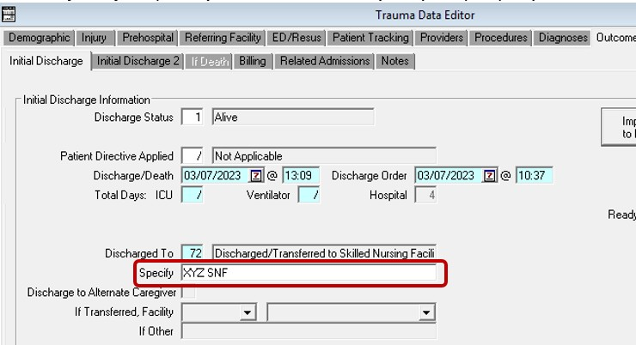
- See example below:

DATA SOURCE: Nursing notes, Discharge Summary, Discharge Orders, Discharge planner notes

Outcome: Transfer Rationale

TAB NAME: Outcome, Initial Discharge

REQUIRED?
YES

ALLOW N/A? YES
ALLOW UNK? YES

REP WRITER NAME: DIS_RS01_AS_TEXT
To read answer as text, add “_AS_TEXT”
otherwise, field info returns as a number

DEFINITION:
The reason the facility was chosen as the next destination for the patient. V5 options:

Specialty Resource Center
Hospital of Choice
Insurance/Health Plan
Repatriation
Specialty Care/Higher Level of Care
Specialty-Other Orthopedics Specialty-Neurosurgery Specialty-Replantation
Specialty-Vascular/Aortic Injuries

Resources Unavailable (Beds, Equipment, Staff, MD) Specialty-Cardiac Bypass

Patient Request
Lower Level of Care Economic
Managed Care Patient
System Protocol Physician/Services Available Other
Specialty-Pediatrics Specialty-Hand Specialty-Spine
Specialty-Pelvic Ring/Acetabular Fxs
Specialty-Orthopedics-Soft Tissue Coverage
Specialty-Facial Trauma Specialty-Burns Ear, Nose and Throat Ophthalmology
Plastic Surgery Orthopedic-Spine Orthopedic-Spine
/ Not Applicable
? Unknown

  - ADDITIONAL INFORMATION:
If the reason for the transfer is unknown by the sending facility, choose 4. Specialty Care/ Higher Level of Care The null value “Not Applicable” is used only for patients who were not transferred out from the ED or after hospital admission to another facility.

:DATA SOURCE:
D/C Summary,, Nursing notes, Progress Notes, Discharge planning notes

Initial Discharge: Impediments to Discharge

TAB NAME: Outcomes: Initial Discharge REQUIRED? NO

ALLOW N/A? NO ALLOW UNK? YES

V5 REP WRITER NAME: IMP_DISS_L_AS_TEXT

DEFINITION:
Reasons for delay in discharge

V5 OPTIONS:
None
Delay in Discharge Plan Financial
Homeless Legal
Non-Availability of Transfer Facility Psychiatric
Social Other
? Unknown

ADDITIONAL INFORMATION:
- None

DATA SOURCE:
Physician progress notes, Case Management Notes, Social Work Notes, Nursing Notes, EMR

Initial Discharge: Ready to Discharge Date

TAB NAME: Outcomes: Initial Discharge REQUIRED? NO

ALLOW N/A? NO ALLOW UNK? YES

V5 REP WRITER NAME: DIS_READY_DATE

DEFINITION:
Date patient is ready for discharge

V5 OPTIONS:
N/A

ADDITIONAL INFORMATION:
- None

DATA SOURCE:
Physician progress notes, Case Management Notes, Social Work Notes, Nursing Notes, EMR

Initial Discharge: Delay Days

TAB NAME: Outcomes: Initial Discharge REQUIRED? NO

ALLOW N/A? NO ALLOW UNK? YES

V5 REP WRITER NAME: DELAY_DAYS

DEFINITION:
Number of days patient’s discharge was delayed

V5 OPTIONS:
N/A

ADDITIONAL INFORMATION:
- Auto-calculates

DATA SOURCE:
N/A

Outcome: If death: Location (of death)

TAB NAME: ALLOW N/A?

Outcome, If Death

YES
REQUIRED? YES

ALLOW UNK? NO

REP WRITER NAME: DTH_LOC_S_AS_TEXT
To read answer as text, add “_AS_TEXT”
Otherwise, field info returns as a number

DEFINITION:
Location in facility when patient died (brain death declared, if applies). V5 options:

Emergency Department Operating Room Intensive Care Unit
Step-Down Unit
Floor
Observation Unit Burn Unit Radiology
Post Anesthesia Care Unit Special Procedure Unit
Labor and Delivery Neonatal/Pediatric Care Unit
/ Not Applicable
? Unknown

ADDITIONAL INFORMATION:

- If patient died, do not use Unknown.
- If patient did not die, software will not open this section to allow data entry.

DATA SOURCE:
D/C Summary, Death Note, Nursing notes, Progress Notes, Patient location data field in EMR

Outcome: Circumstances of Death

TAB NAME: ALLOW N/A?

Outcome, Circumstances of Death

YES
REQUIRED? YES

ALLOW UNK? YES

REP WRITER NAME: DTH_CIRC_AS_TEXT
To read answer as text, add “_AS_TEXT”
otherwise, field info returns as a number

DEFINITION:
What caused the patient to die?

V5 Options:
Burn Shock Burn Wound
Cardiovascular Failure
Multiple Organ (Metabolic) Failure Pre-Existing Illness
Pulmonary Failure Sepsis
Trauma Shock Trauma Wound Other
Not Applicable Unknown

ADDITIONAL INFORMATION:
- Applies to all patient deaths.
- Autopsy findings/ ME reports often provide information regarding the cause of death and may add
information about the patient’s medical status and/or injuries that may be unknown at the time of death.

DATA SOURCE:
MD documentation, History & Physical (H&P), Discharge summary, Death note, Autopsy Report/ME findings

If Death: Withdrawal of Care

TAB NAME: Outcomes: If Death REQUIRED? NO

ALLOW N/A? NO ALLOW UNK? YES

V5 REP WRITER NAME: WITHDRAW_CARE_YN

DEFINITION:
Did patient have withdrawal of care

V5 OPTIONS:
Yes No
? Unknown

ADDITIONAL INFORMATION:
  - None

DATA SOURCE:
Death charting, Physician Progress Notes, Nursing Notes

Outcome: If death: Was autopsy performed?

TAB NAME: ALLOW N/A?

Outcome, If Death

YES
REQUIRED? YES

ALLOW UNK? YES

REP WRITER NAME: AUT_YN_AS_TEXT
To read answer as text,
add “_AS_TEXT”, otherwise field info returns as a number

DEFINITION:
Was an autopsy performed on patient (private or by state medical examiner)

V5 options:
Yes No / Not Applicable ? Unknown

ADDITIONAL INFORMATION:
- Applies to all patient deaths
- Report “Yes” for Forensic/Full autopsies and External/View Only autopsies. An external autopsy refers to a detailed examination of the patient without dissection. A forensic autopsy refers to detailed examination including dissection. Both types of autopsy qualifies for this field.

DATA SOURCE:
MD documentation, History & Physical (H&P), Discharge summary, Death note, Autopsy report

New Field

Outcome: If death: Was Organ Donation Referral Made to LifeLink?

TAB NAME:

Outcome, If Death
REQUIRED? YES

ALLOW N/A? YES
ALLOW UNK? YES

Rep Writer Name:
TBD

Definition:
Was referral made to LifeLink organ procurement organization upon death?

V5 Options:

Yes No
/ N/A
? Unknown

Additional Information:
  - Applies to all deaths

Data Sources:
Organ Procurement Agency documentation, Social Services, Palliative Care or Chaplin notes, Discharge/ Death summary, Nursing notes, MD documentation, Provider Progress notes

New Field
Outcome: If Death: Did the Patient Qualify as an Organ Donor?

TAB NAME: Outcome, If Death ALLOW N/A? YES
Yes
REQUIRED? YES

ALLOW UNK? YES

Rep Writer Name:
TBD

Definition:

Did patient meet qualifications to become organ donor through after referral call to LifeLink organ procurement organization?

V5 Options:

Yes No / N/A ? Unknown

Additional information:
- Applies to all deaths

Data Sources:
Organ Procurement Agency documentation, Social Services, Palliative Care or Chaplin notes, Discharge/ Death summary, Nursing notes, MD documentation, Provider Progress notes

Outcome: If death: Organ Donor?

TAB NAME: ALLOW N/A?

Outcome, If Death

YES
REQUIRED? YES

ALLOW UNK? YES

REP WRITER NAME: ORG_DONOR_YN_AS_TEXT
To read answer as text, add “_AS_TEXT”
Otherwise, field info returns as a number

DEFINITION:
Was the patient a qualified organ/tissue donor? Answers for this field includes:

ADDITIONAL INFORMATION:
- Applies to all patient deaths
- If organs were donated, answer “Yes” to all three organ donation fields.

DATA SOURCE:
Organ Procurement Agency documentation, Social Services, Palliative Care or Chaplin notes, Discharge/Death summary, Nursing notes, MD documentation, Provider Progress notes

Outcome: If death: Was organ donation requested?

TAB NAME: ALLOW N/A?

Outcome, If Death

YES
REQUIRED? YES

ALLOW UNK? YES

REP WRITER NAME: ORG_STAT_YN_AS_TEXT
To read answer as text,
add “_AS_TEXT”, otherwise field info returns as a number

DEFINITION:
If the patient qualified as an organ/tissue donor, was permission for donation request? Answers for this field includes:

ADDITIONAL INFORMATION:
- Applies to all patient deaths
- If organs were donated, answer “Yes” to all three organ donation fields.

DATA SOURCE:
Nursing notes, MD documentation, Provider Progress note, Organ Procurement Agency documentation, Social Services, Palliative Care or Chaplin notes, Discharge/Death summary

Outcome: If death: Was request granted?

TAB NAME: ALLOW N/A?

Outcome, If Death

YES
REQUIRED? YES

ALLOW UNK? YES

REP WRITER NAME: ORG_GR_YN_AS_TEXT
To read answer as text,
add “_AS_TEXT”, otherwise field info returns as a number

DEFINITION:
If the patient qualified as an organ/tissue donor and donation permission requested, was request for donation granted / agreed to by legal next of kin? Answer choices include:

ADDITIONAL INFORMATION:
- Applies to all patient deaths.
- If organs were donated, answer “Yes” to all three organ donation fields.

DATA SOURCE:
Nursing notes, MD documentation, Provider Progress note, Organ Procurement Agency documentation, Social Services, Palliative Care or Chaplin notes, Discharge/Death summary

Outcome: If death: Organs Procured

TAB NAME: Outcome, If Death
REQUIRED? YES

ALLOW N/A?
YES
ALLOW UNK? YES

REP WRITER NAME: ORG_DNR01 through ORG_DNR20
AS_TEXT To read answer as text,
add “_AS_TEXT”, otherwise field info returns as a number

DEFINITION:
If the patient qualified as an organ/tissue donor and donation was granted, report the organ(s) procured

V5 Options:
None
Adrenal Glands Bone
Bone Marrow Cartlidge Corneas
Dura Mater Fascialata Heart
Heart Valves

Intestine Kidney Liver Lungs Nerves Pancreas Skin Stomach Tendons
Whole Eyes

Other
? Unknown

ADDITIONAL INFORMATION:
- Applies to all patient deaths.
- Must answer “Yes” to Outcome: If Death: Organ Donor.

DATA SOURCE:
Nursing notes, MD documentation, Provider Progress note, Life Link/ Organ Procurement Agency documentation, Social Services, Palliative Care or Chaplin notes, Discharge/Death summary, Operative reports for organ procurement

If Death:Donor Status

TAB NAME: Outcomes: If Death REQUIRED? NO

ALLOW N/A? NO ALLOW UNK? YES

V5 REP WRITER NAME: DNR_STAT

DEFINITION:
The status of the patient at the time the organs were donated at your facility.

V5 OPTIONS:
Brain Death
Non-Beating Heart
? Unknown

ADDITIONAL INFORMATION:
  - Only opens when organs procured section completed

DATA SOURCE:
Death charting, Physician Progress Notes, Nursing Notes, OR records

If Death: Date and Time Organs Procured

TAB NAME: | Outcomes: If Death | REQUIRED? NO
ALLOW N/A? | NO | ALLOW UNK? YES

V5 REP WRITER NAME: ORG_PROCURE_EVENT

DEFINITION:
The date and time the organs were donated at your facility

V5 OPTIONS:
N/A

ADDITIONAL INFORMATION:
- Only opens if organs procured section is populated.

DATA SOURCE:
Death charting, Physician Progress Notes, Nursing Notes, OR records

QA Items: ACS Questions

TAB NAME: QA Tracking: QA Items REQUIRED? NO

ALLOW N/A? NO ALLOW UNK? YES

V5 REP WRITER NAME: FLT_QA_YNS_L_AS_TEXT

DEFINITION:
Legacy defined QA Item questions defined by ACS prior to the ITDX/TQIP standard. NOTE: These are optional and not required.

V5 OPTIONS:
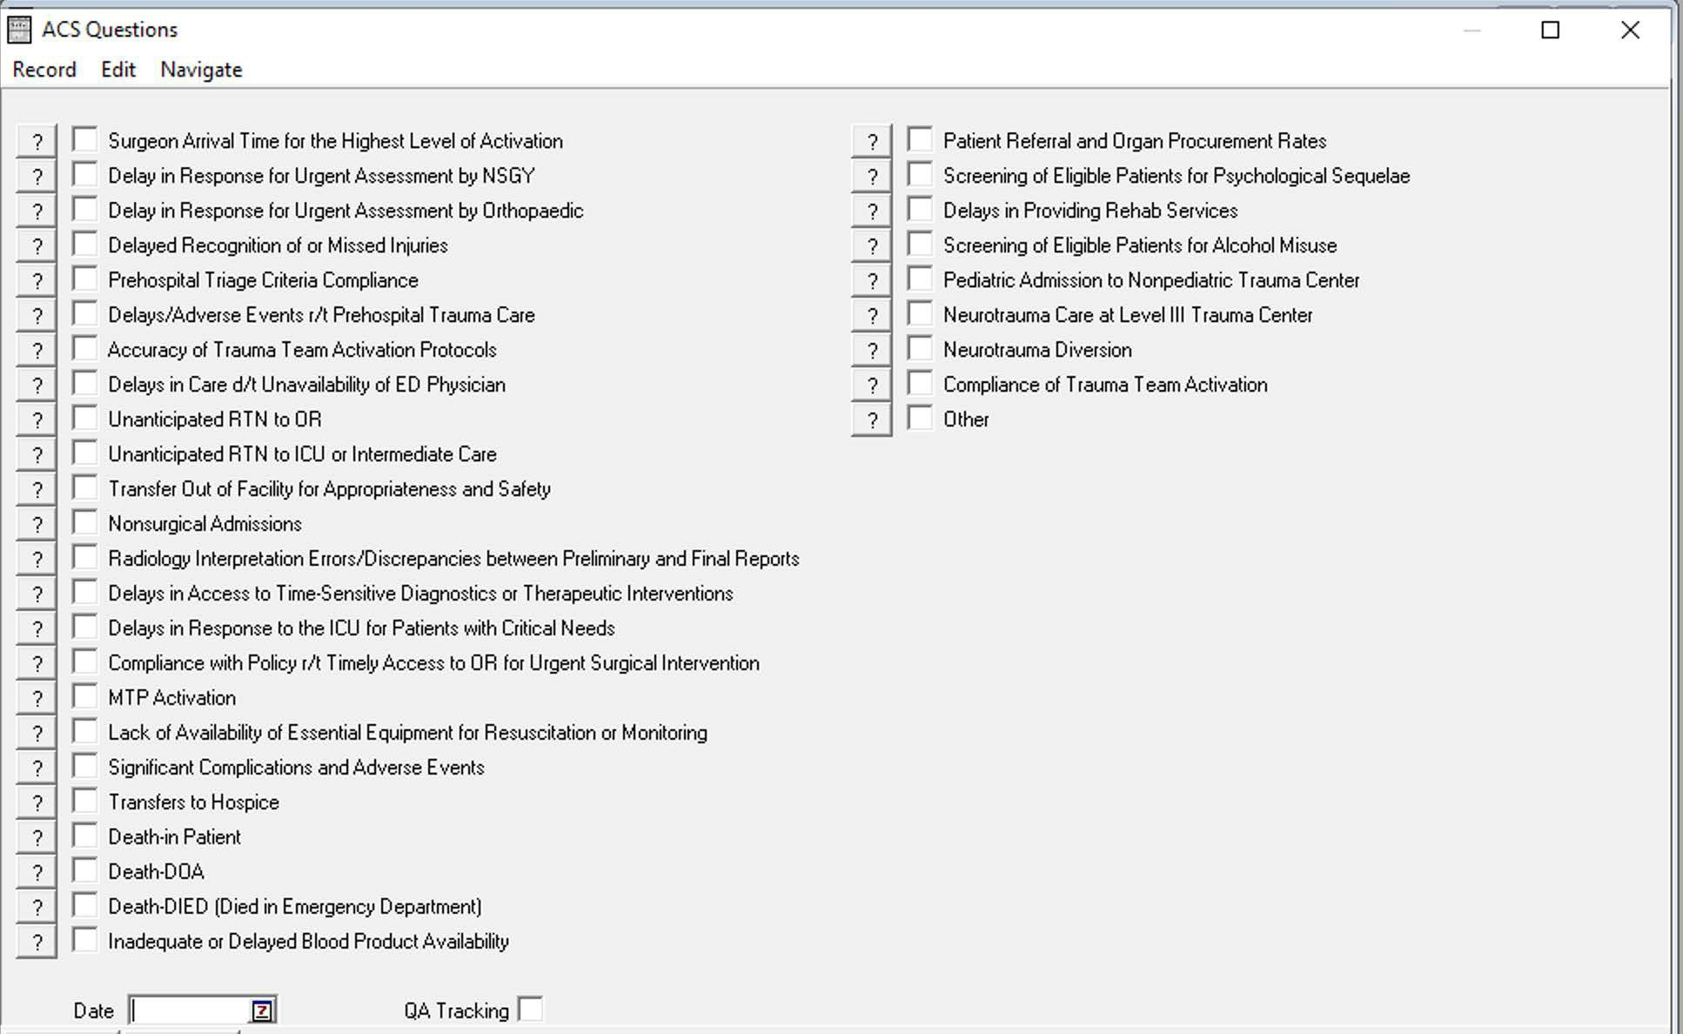

ADDITIONAL INFORMATION:
- None

DATA SOURCE:
Physician Progress Notes, Nursing Notes, EMR

QA: QA Items

TAB NAME: QA Tracking: QA Items REQUIRED? NO

ALLOW N/A? NO ALLOW UNK? YES

V5 REP WRITER NAME: FLT_CODES_L_AS_TEXT

DEFINITION:
Any defined hospital event (complication, occurrence, filter, outlier) that occurred after injury including prehospital, transfer to and during the patient's stay at your hospital that is not part of the ITDX/TQIP defined standard. This includes any user-defined filters.

V5 OPTIONS:
*Multiple items available to pick or users can add their own options

ADDITIONAL INFORMATION:
- None

DATA SOURCE:
Death charting, Physician Progress Notes, Nursing Notes, OR records

